## horizontal line



Practical Task Examination: TACoin

CSE233 Fall 2021

**─**

Mohamed Mokhtar Abdelrasoul

18P7232

Group 2 - Section 2

ASU - CESS

# Part 1

## Using Github

Github repo: <https://github.com/Mmokhtar/AgilePracticalExam>

## Using Jira

### Create your project and provide a short description

Project Description: TACoin (Token Acquisition Coin) is a coin aimed at standardizing the creation and deployment of blockchain tokens (both fungible and non-fungible) which represent both digital and real-life assets. The main advantage of TACoin’s system is the fact that it is both HTTP-based, and does not rely on the blockchain for the code that can be implemented off the blockchain network (unlike Ethereum).

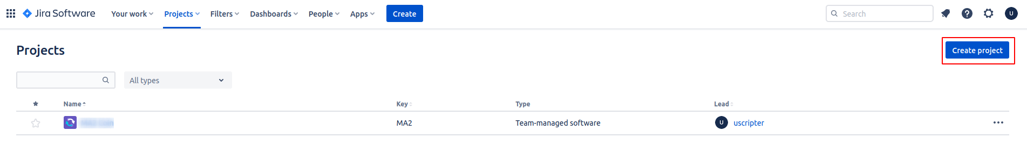

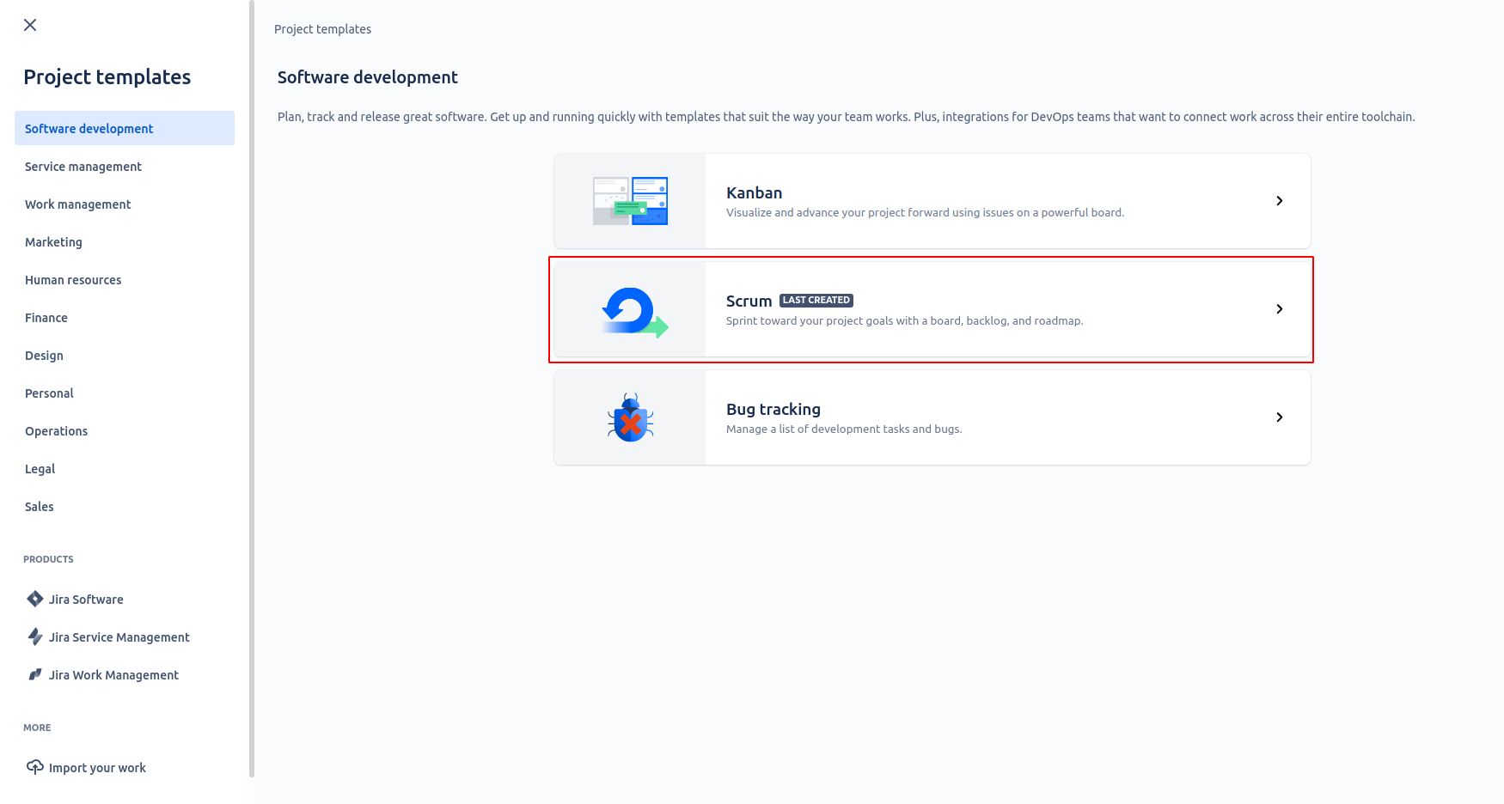

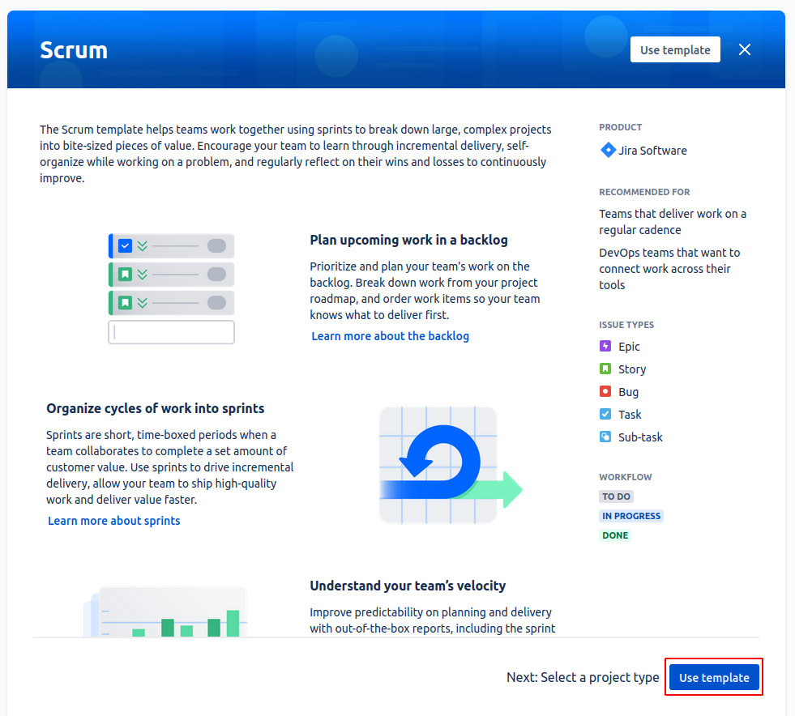

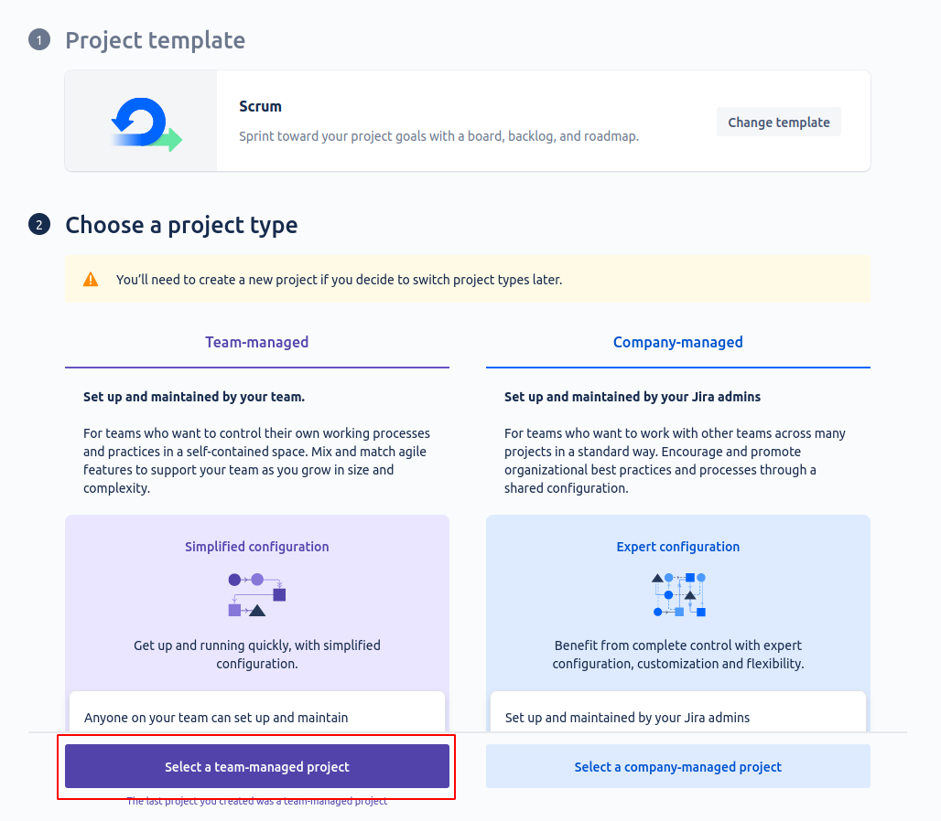

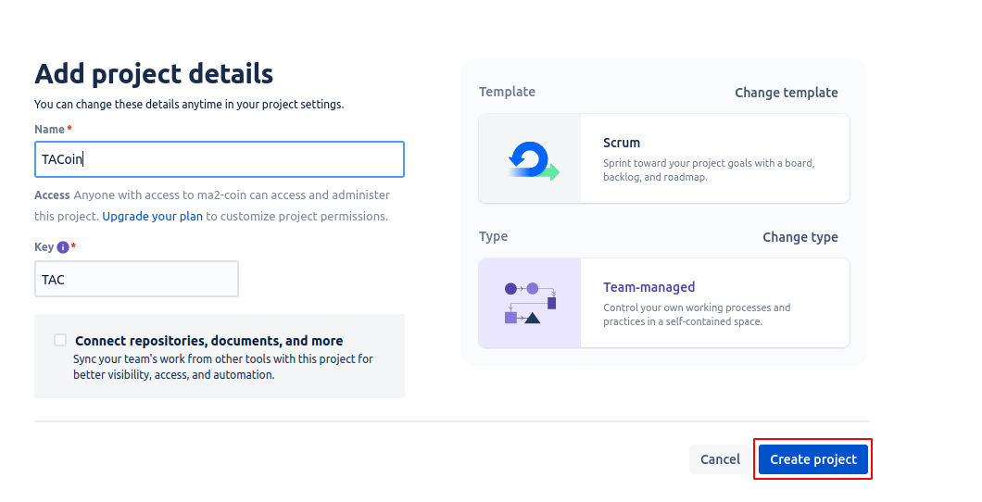

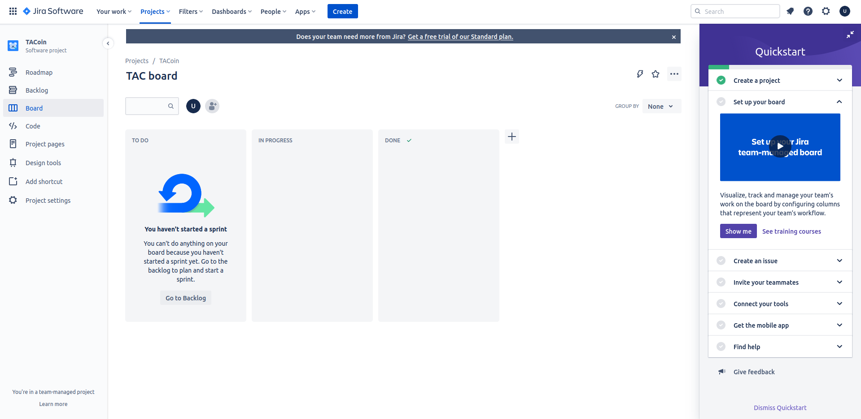

### Create a product backlog that includes at least 10 stories divided into epics. Each item should contain a title, a user story, an estimation in story points, an assignee, and additional details if needed.

**Due to the inability to assign multiple teammates to the same story in Jira, all the stories and the assigned teammates for each story is in the README.md**

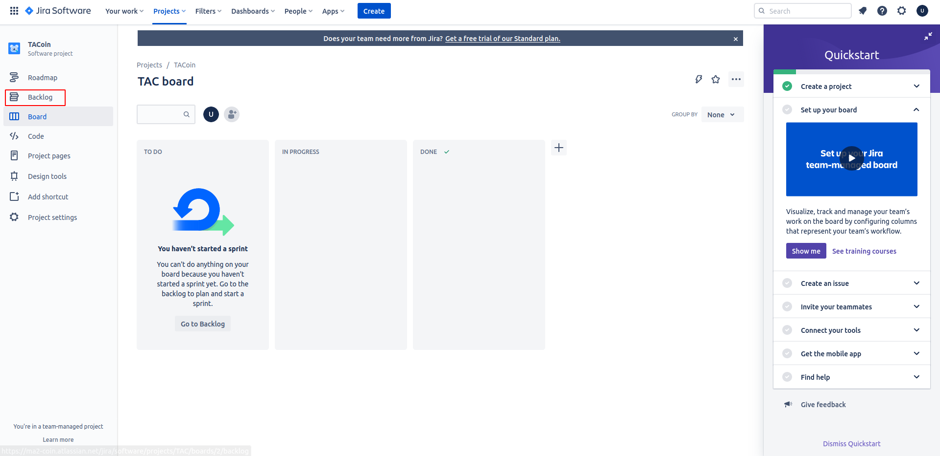

Now we start creating our user stories:

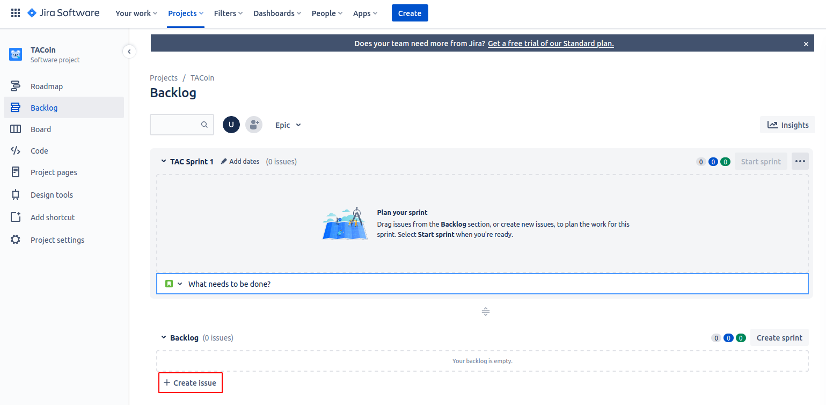

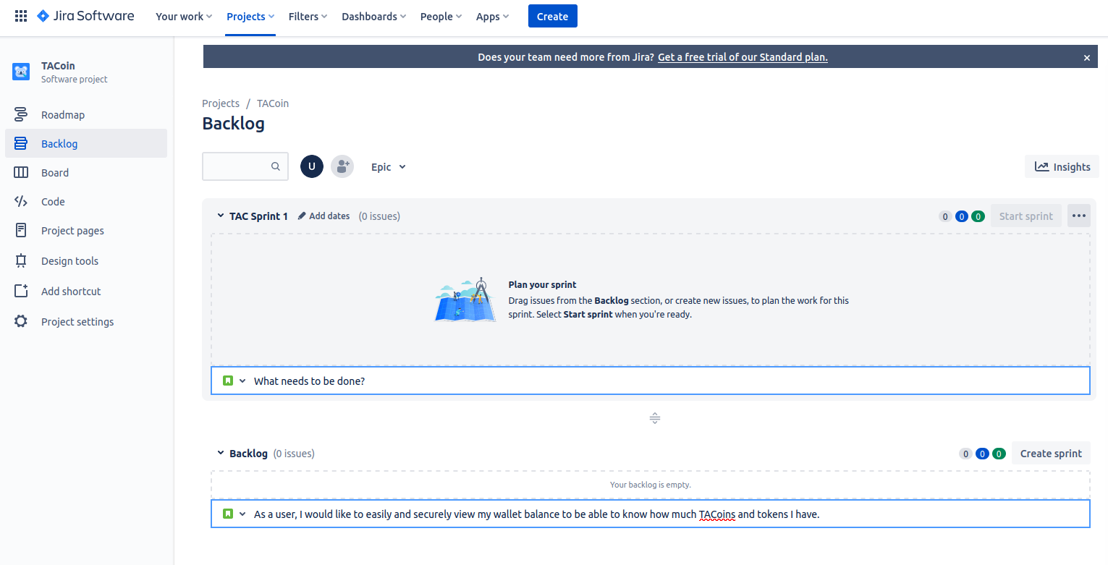

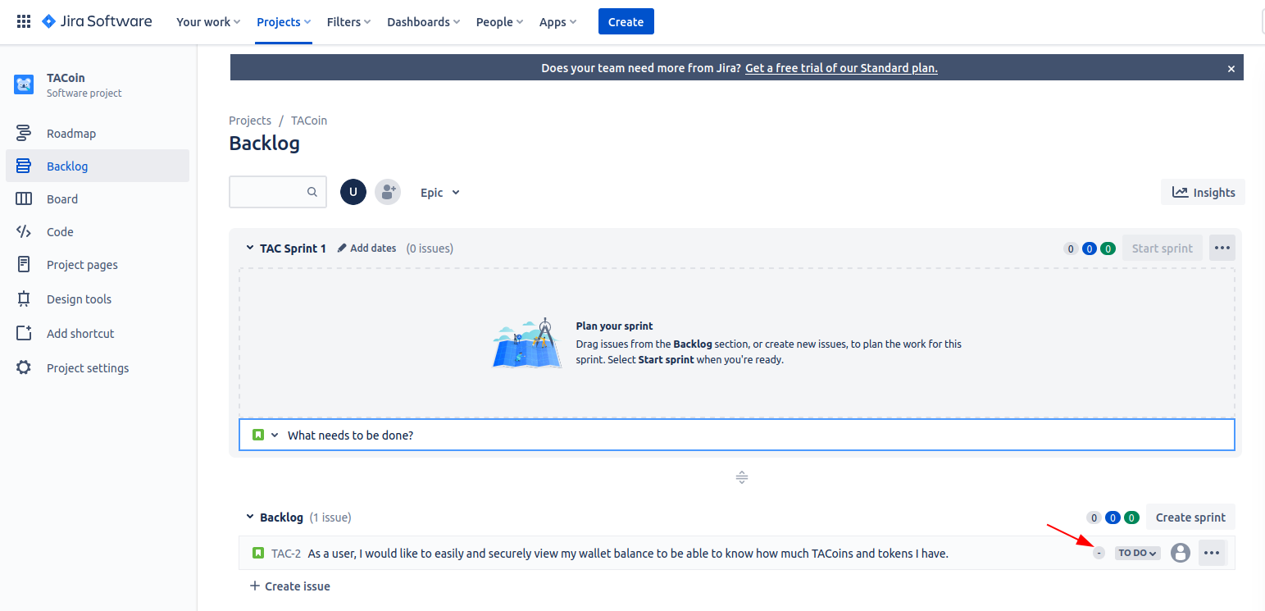

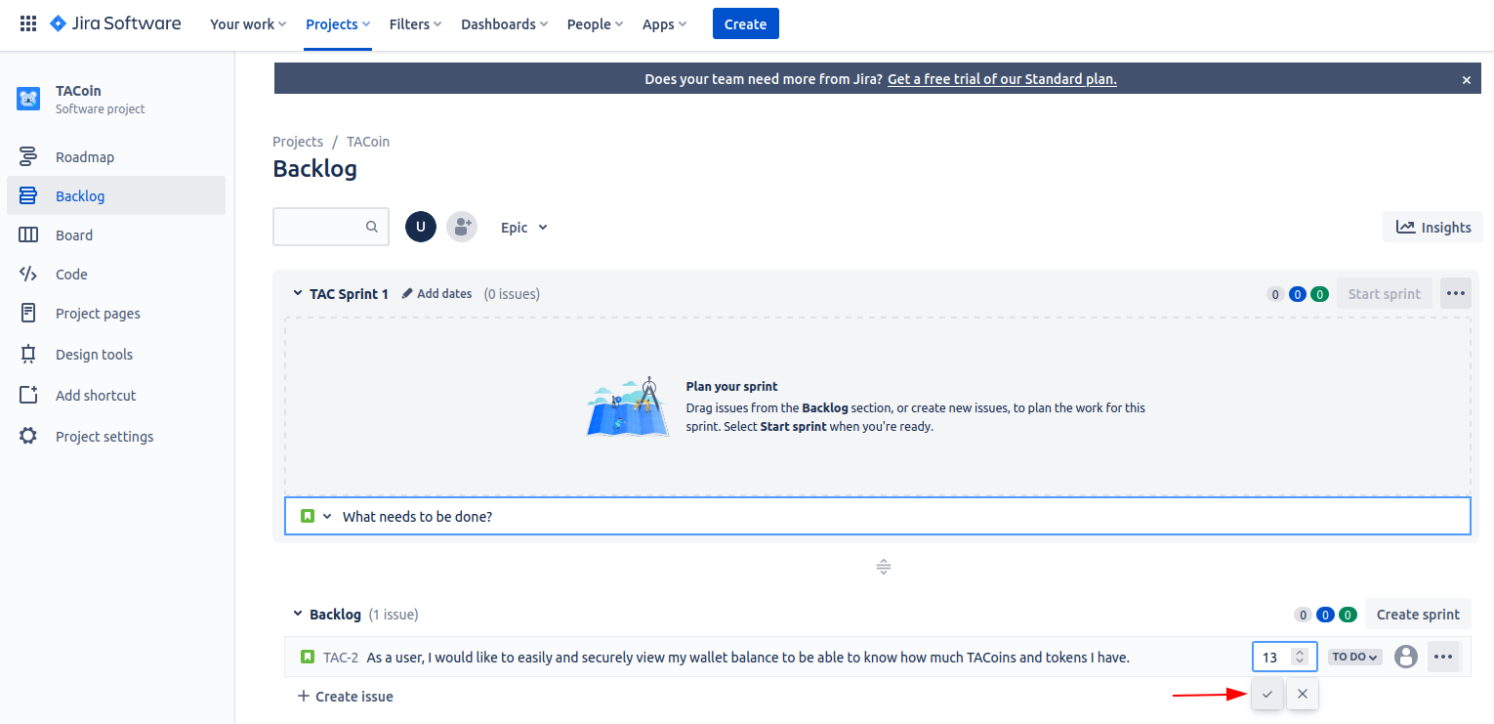

Then the same steps were repeated for all the other user stories.

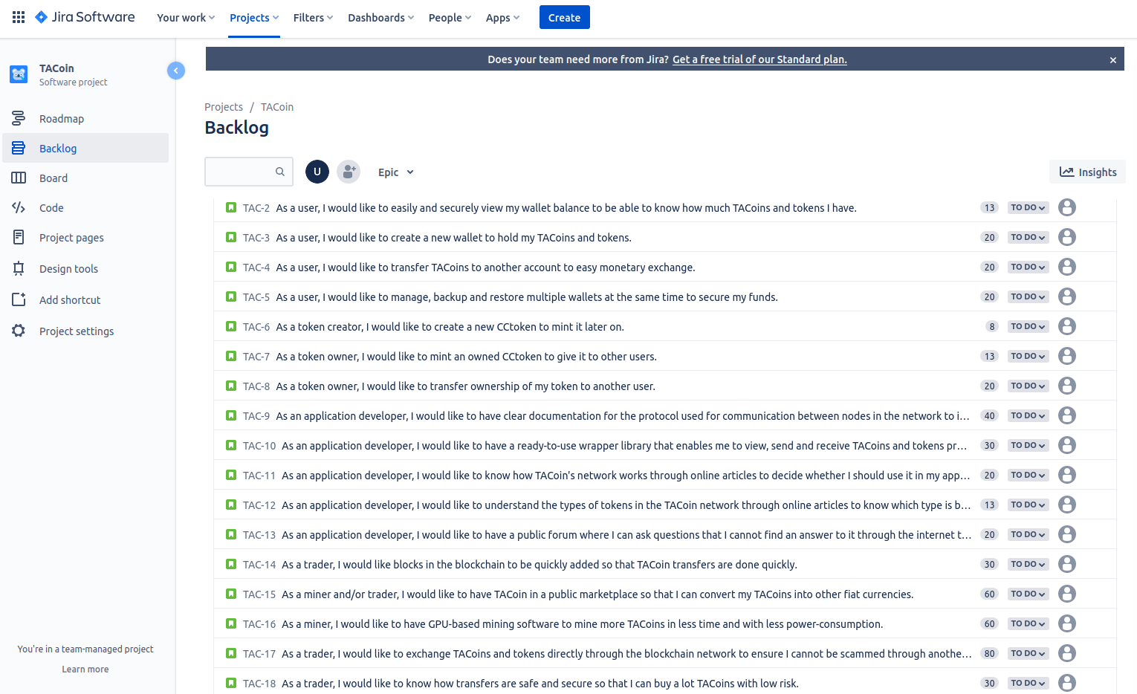

Then we start creating the epics:

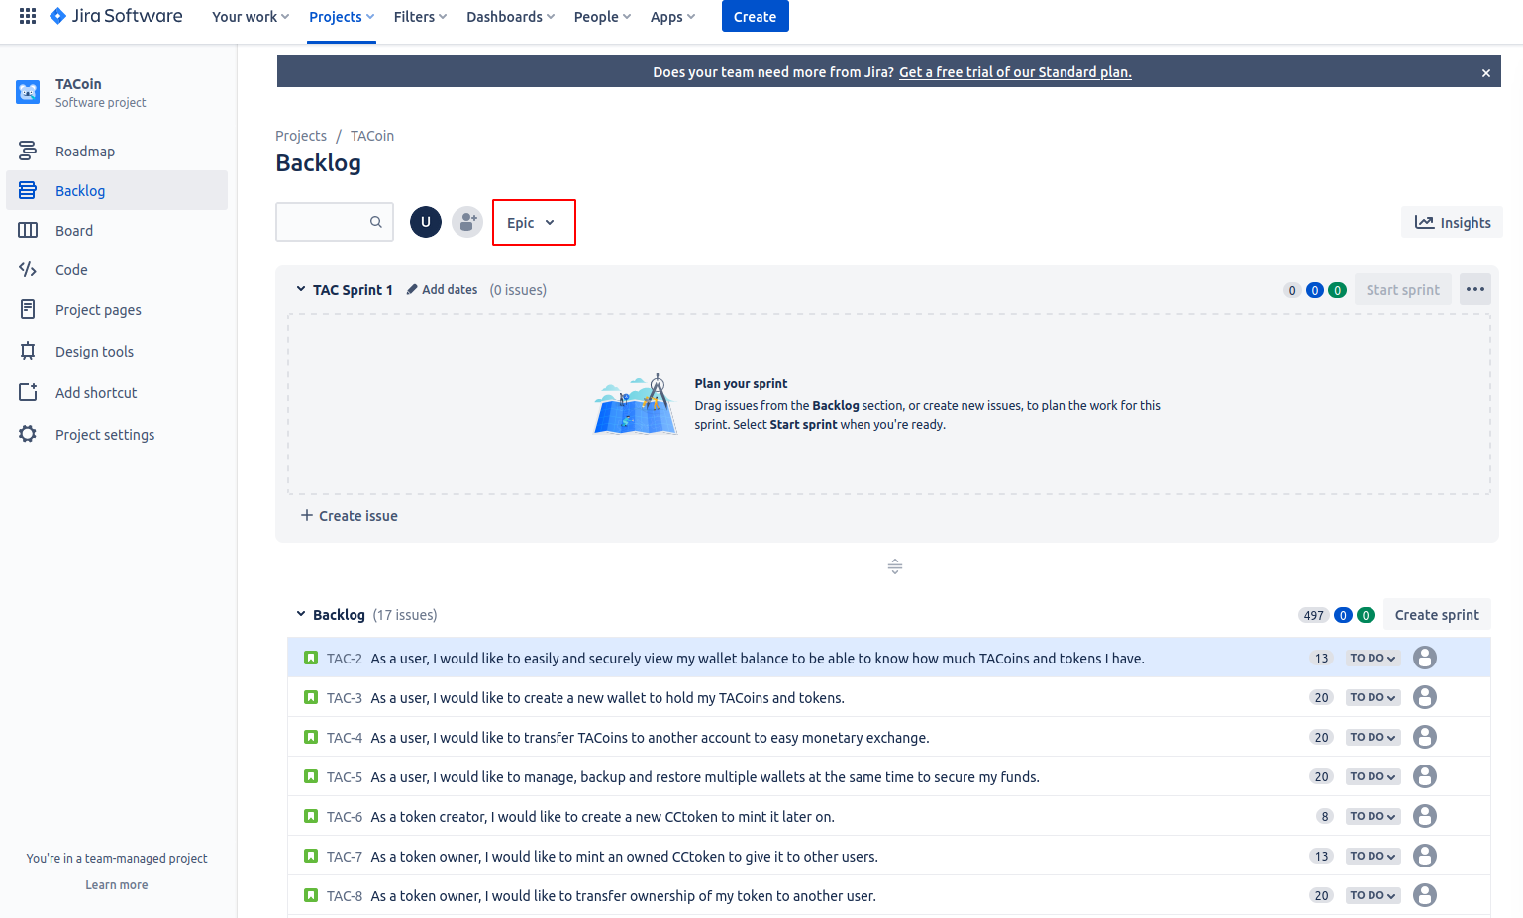

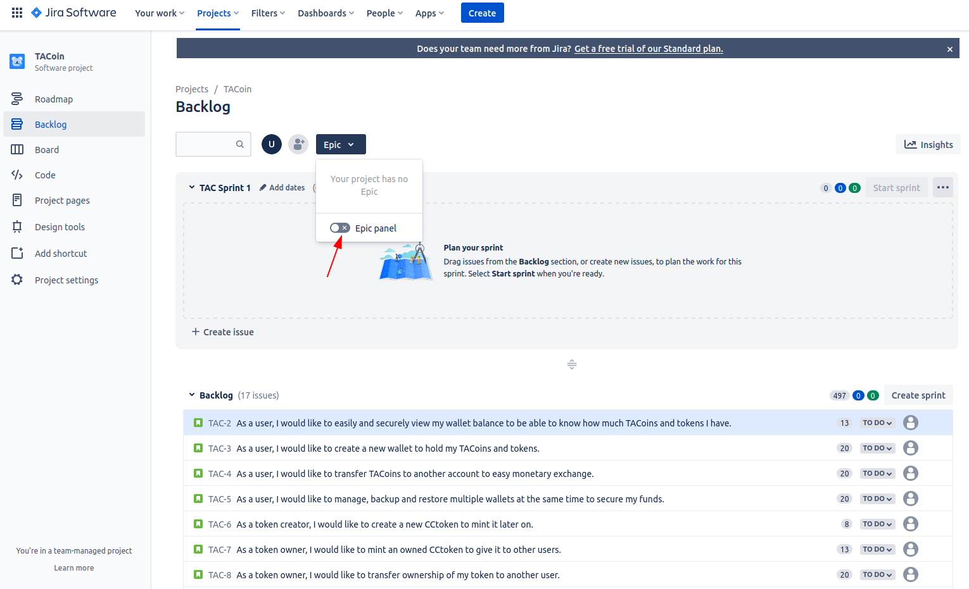

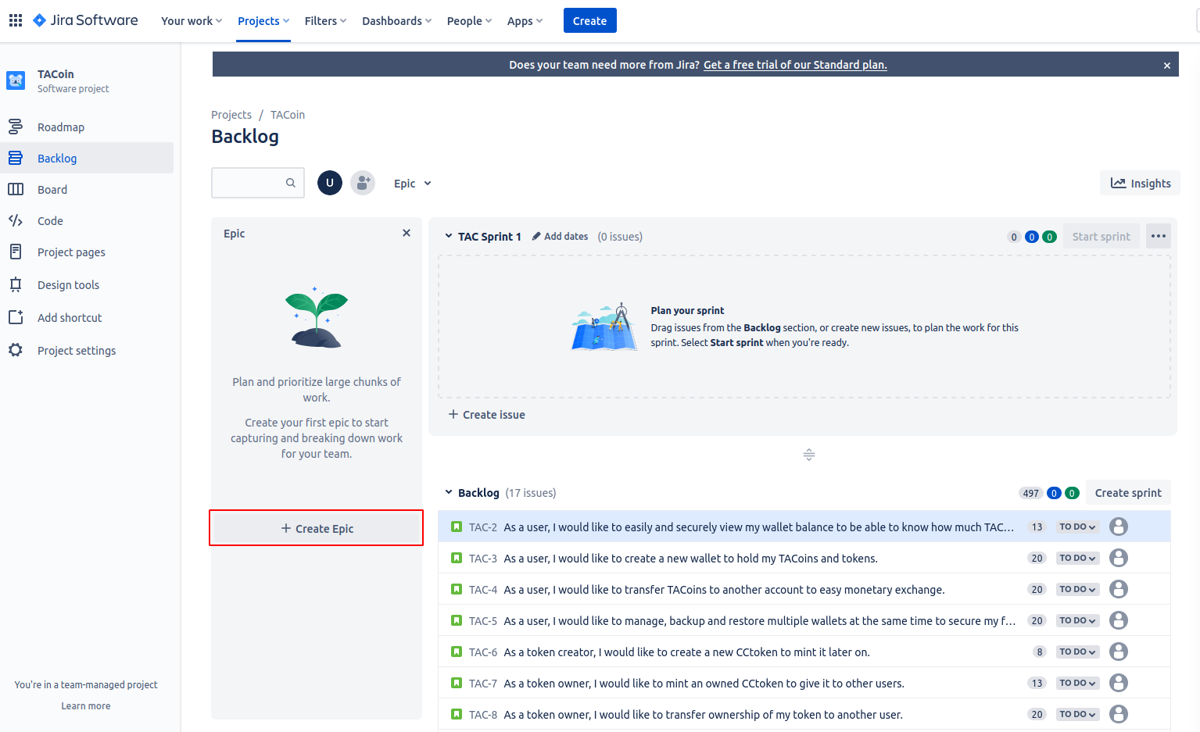

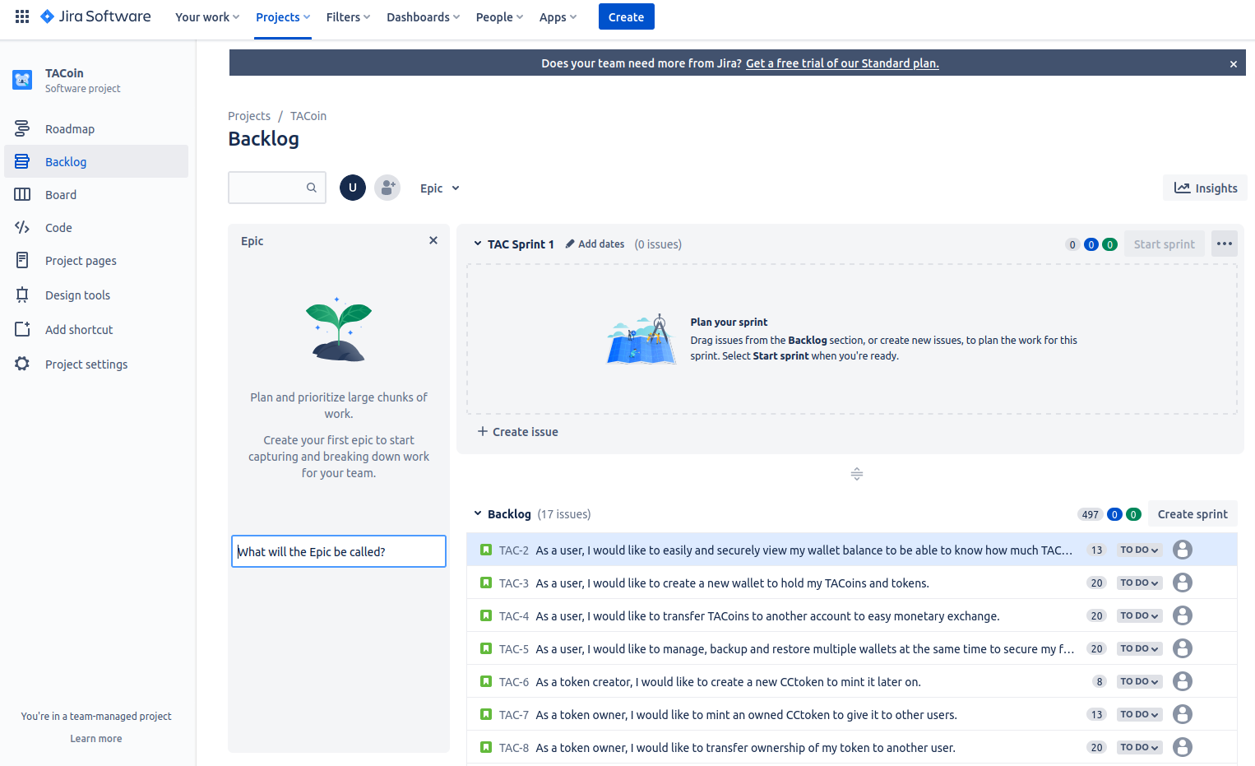

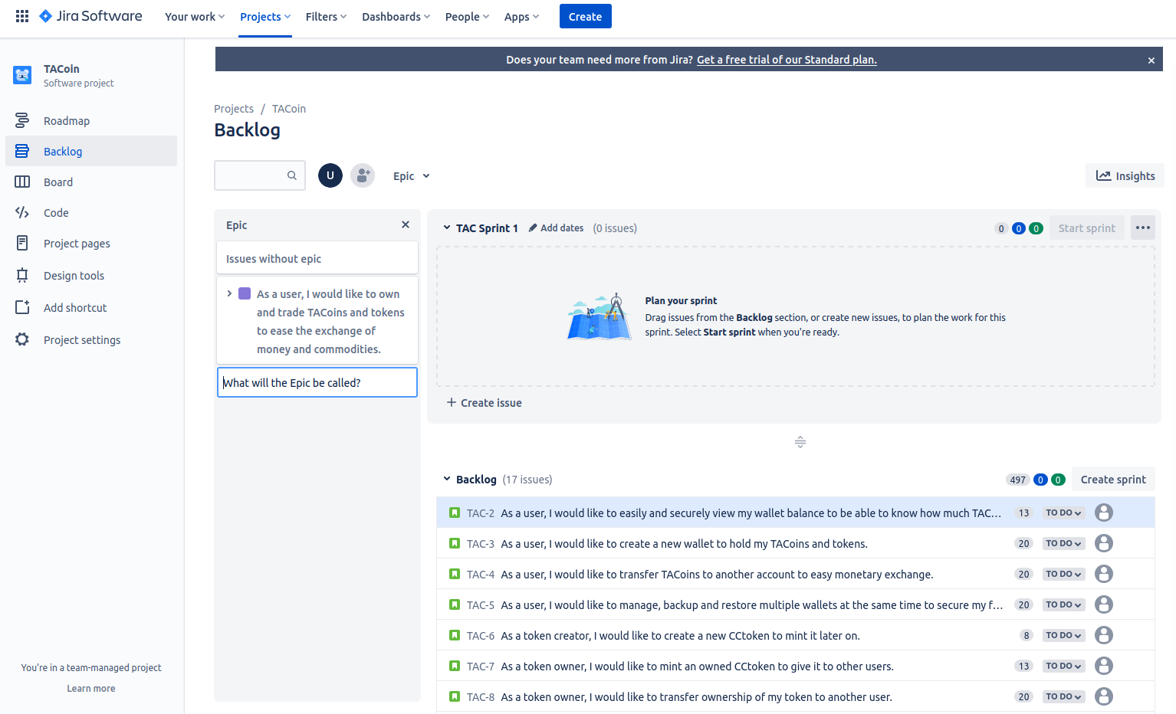

The same steps were repeated for the two other epics.

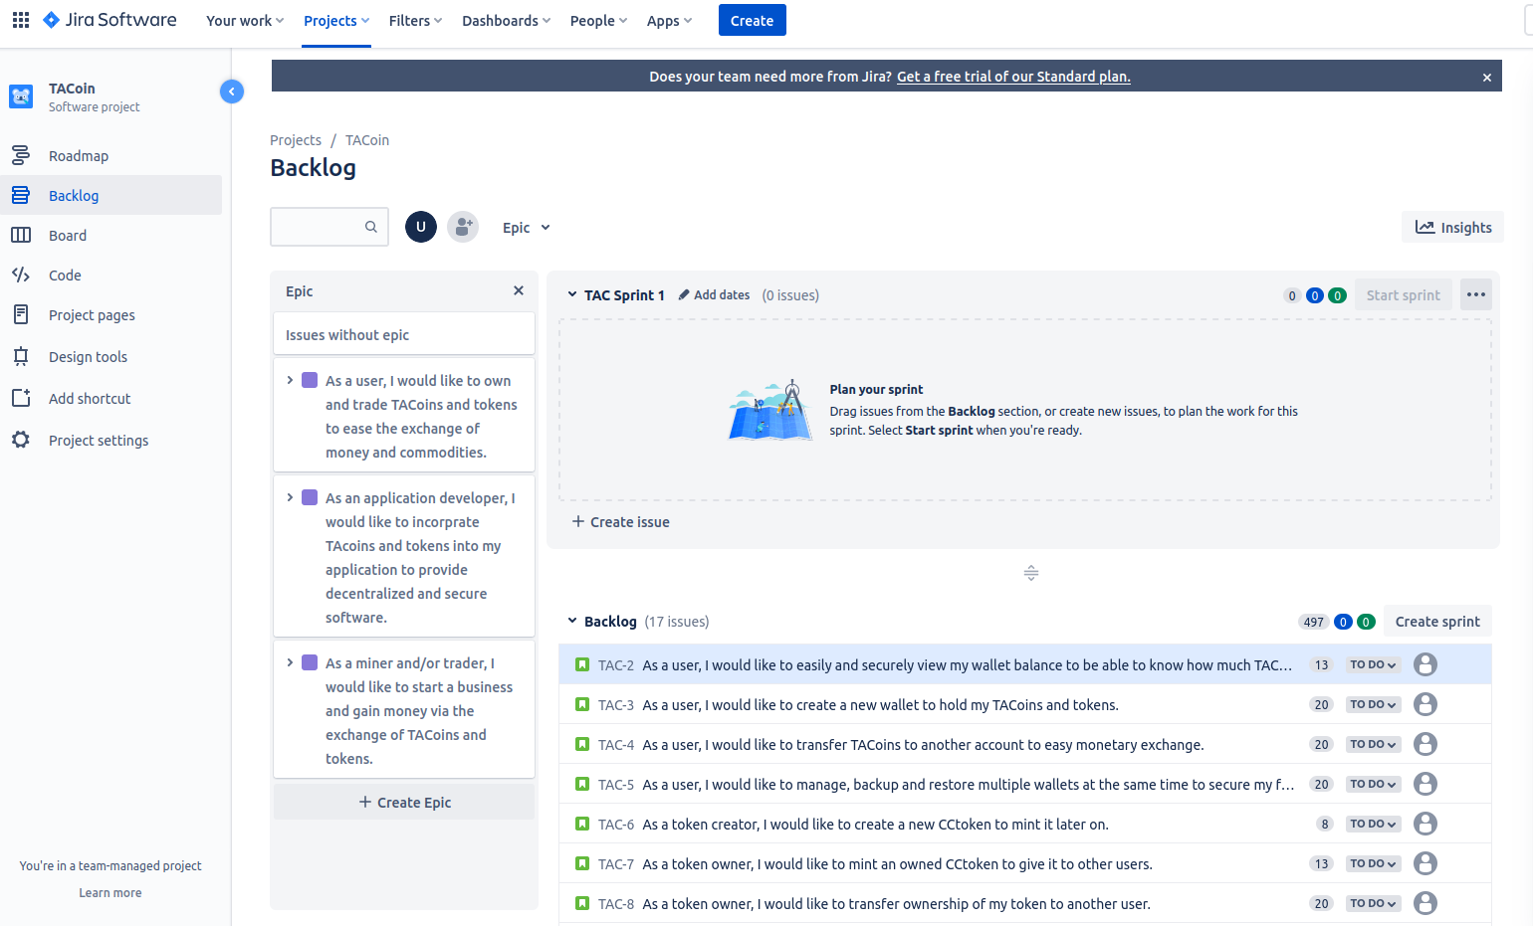

And now we assign the stories to epics:

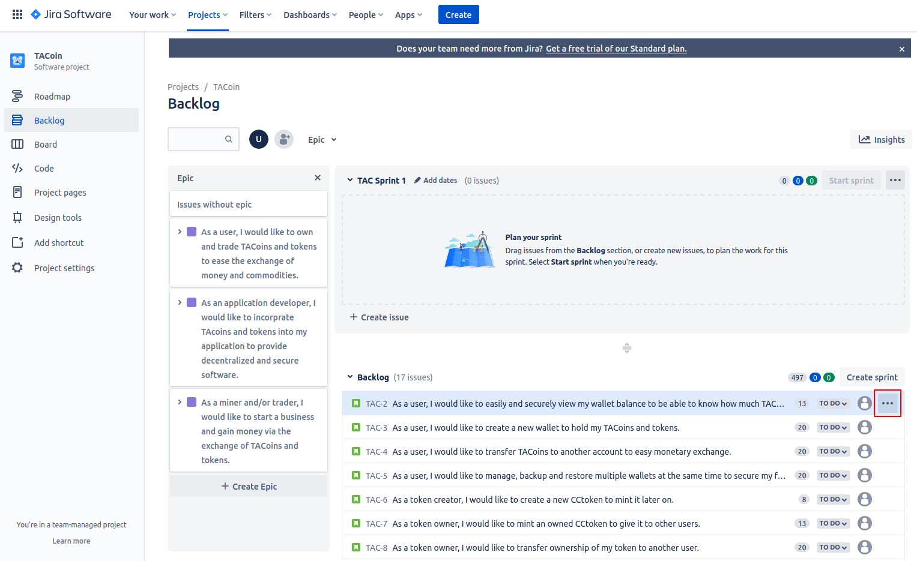

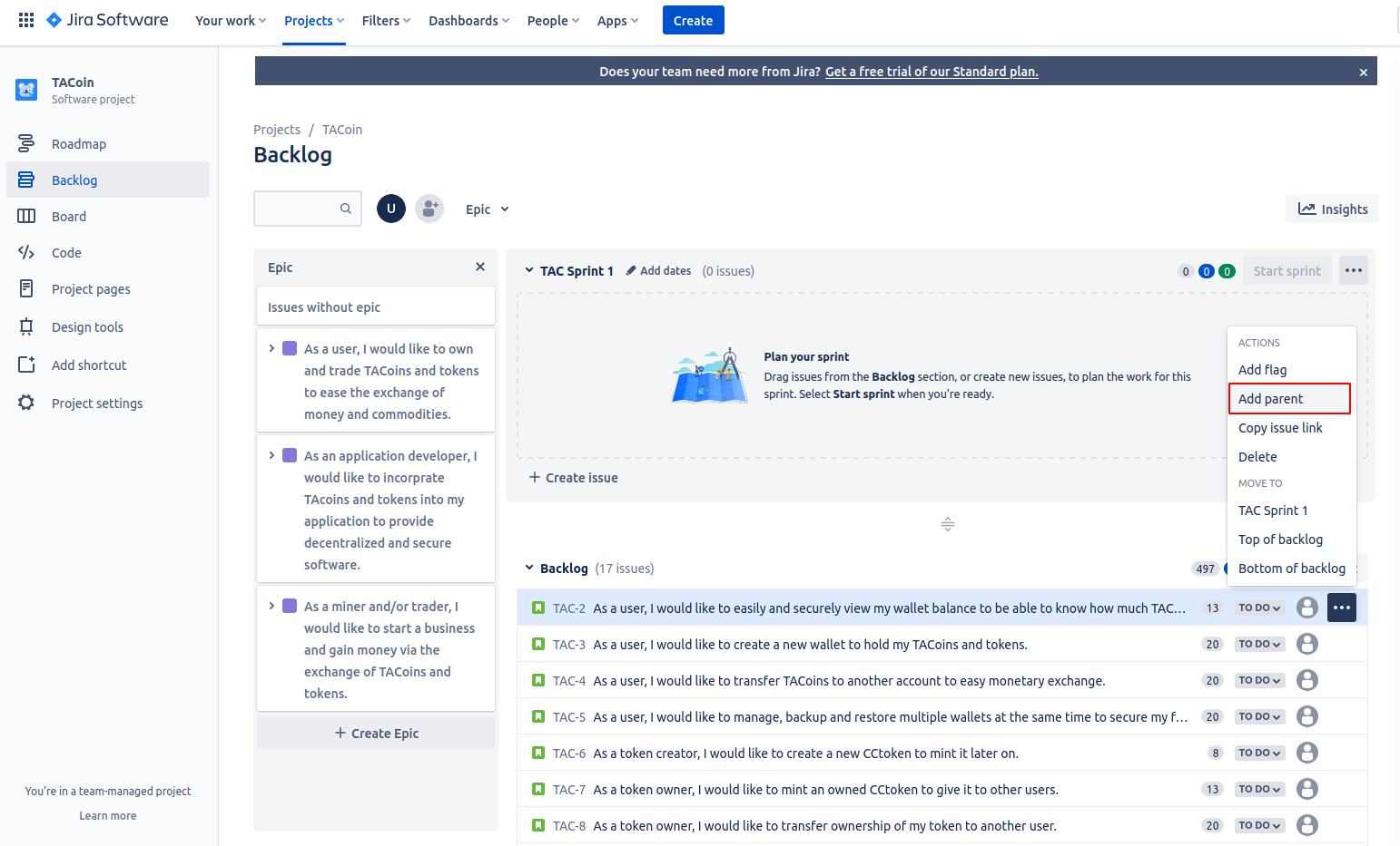

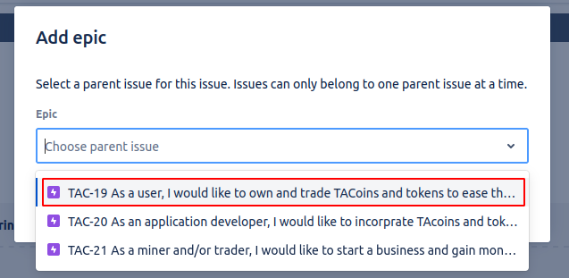

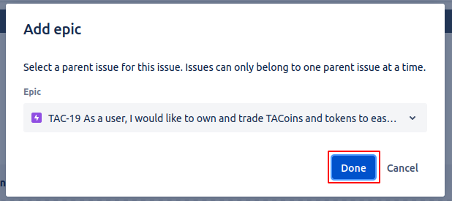

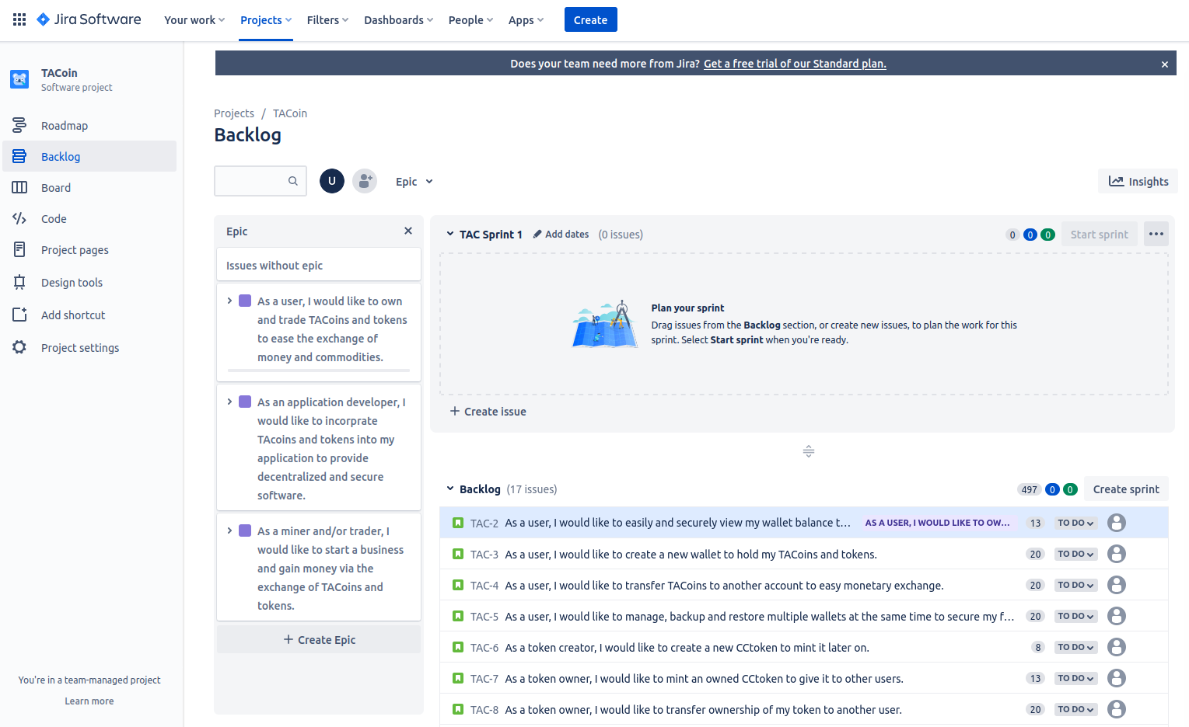

The same steps were repeated for all other stories:

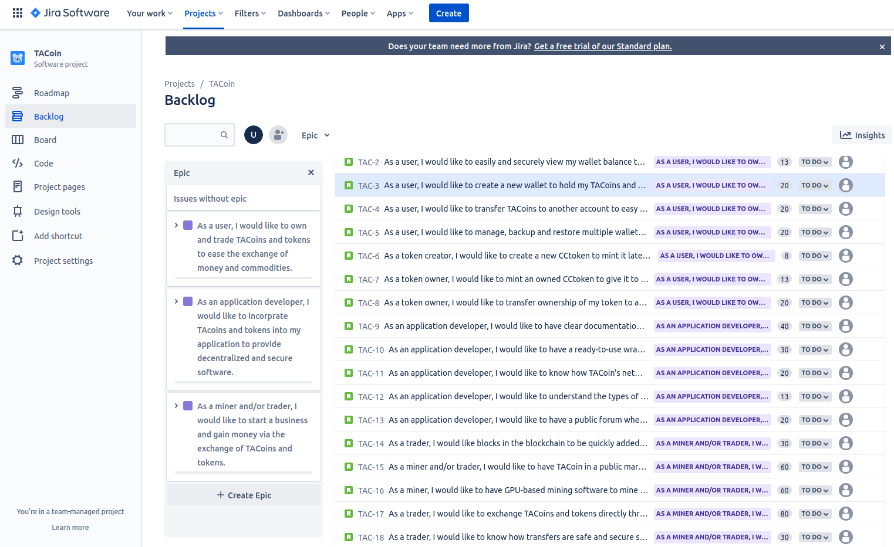

**Then the items were ordered as per the convention stated in the README.md and in the answer for questions 3&4.**

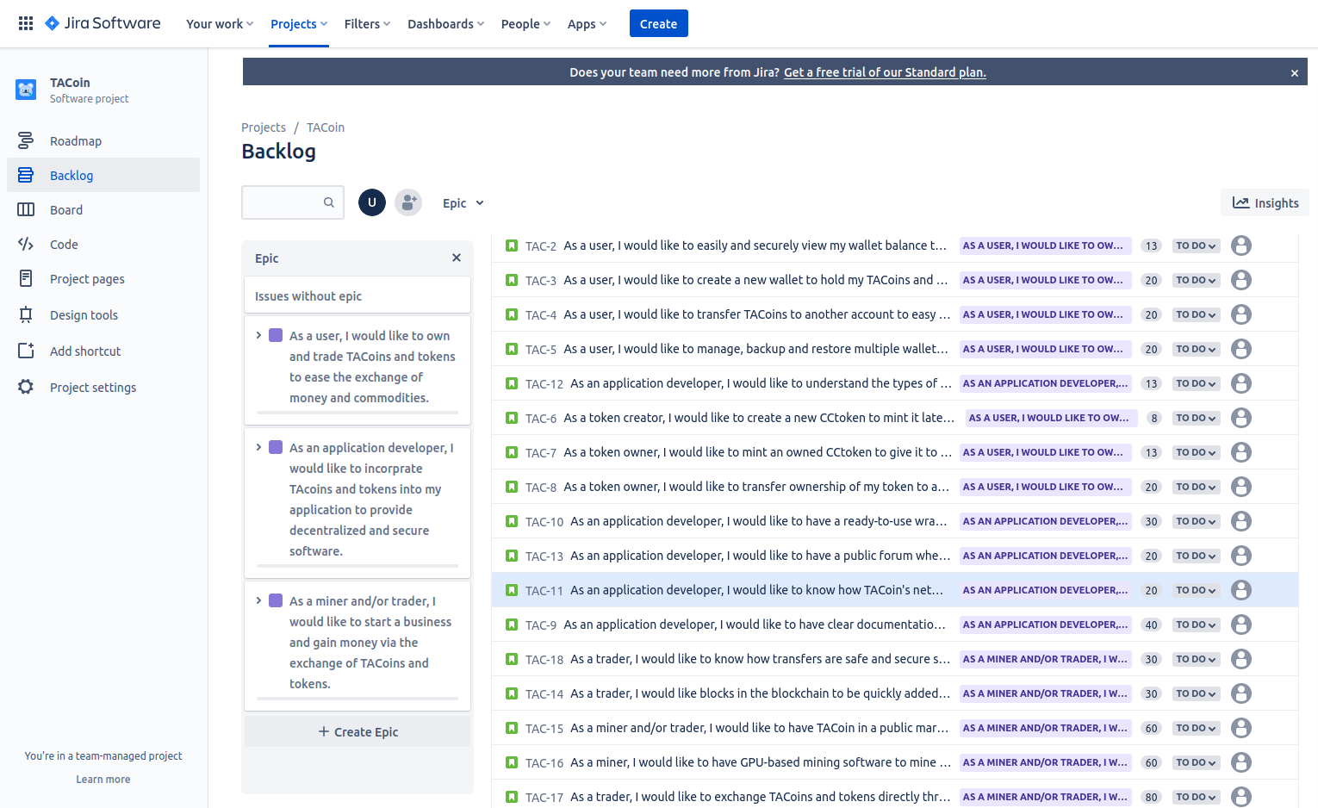

### You should indicate the convention you will use regarding the story point estimation.

### Order your product backlog items and your rationale must be stated in the git README

***Answer for both 3 & 4: (The rationale and convention are also in the README.md)***

The items in the product backlog are ordered according to the value given to stakeholders. This value is decided according to how much it makes the cryptocurrency usable for the real-life use cases of the coin. For example, TACoins themselves are more important than tokens because the exchange of money is more common in real life than the exchange of commodities. Moreover, exchanging commodities for money (TACoin) is prioritized because it is more common than exchanging them with other commodities, so that is also prioritized.

Things to note:

* The sprint size is initially 2 weeks
* The average story-points per sprint is 90 story points
* A story must be at max 30 story points before going into a sprint
* Epics are sized anywhere from 100 to XXL, and do not follow the fibonacci sequence (can be in any range between 100 and 200)

Story points are estimated in a modified fibonacci sequence, then in the form of T-shirt sizes as follows:

* 1: 10-20 of them can be done in a productive work day
* 2: 6-9 of them can be done in a productive work day
* 3: 3-6 of them can be done in a productive work day
* 5: 2-3 of them can be done in a productive work day
* 8: 1-2 of them can be done in a productive work day
* 13: Takes about 1 productive work day
* 20: Takes about 1-2 productive work days
* 30: Takes about 2-3 productive work days
* 40: Takes about 2-4 productive work days
* 60: Takes about 4-6 productive work days
* 80: Takes about 6-8 productive work days
* 100: Takes about 8-10 productive work days [Epic Sized]
* 200: Takes about 10-20 productive work days [Epic Sized]
* L: Takes about 20-40 productive work days [Epic Sized]
* XL: Takes about 40-60 productive work days [Epic Sized]
* XXL: Takes about 60-80 productive work days [Epic Sized]

* A productive work day is meant for the whole team

# Part 2

# Using Github

Github repo: <https://github.com/Mmokhtar/AgilePracticalExam>

The average story-points per sprint (for this team) is 90 story points.

The two daily Scrum documents (one for each sprint) can be found [here](https://docs.google.com/spreadsheets/d/1PmwSIqlR63wPKU5sStW_wMGMCKIjT-waAUNeVpitzqA/edit?usp=sharing): <https://docs.google.com/spreadsheets/d/1PmwSIqlR63wPKU5sStW_wMGMCKIjT-waAUNeVpitzqA/edit?usp=sharing> 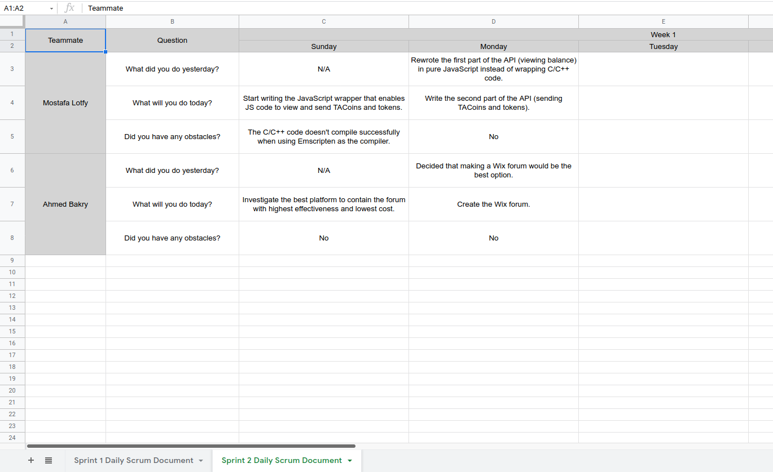

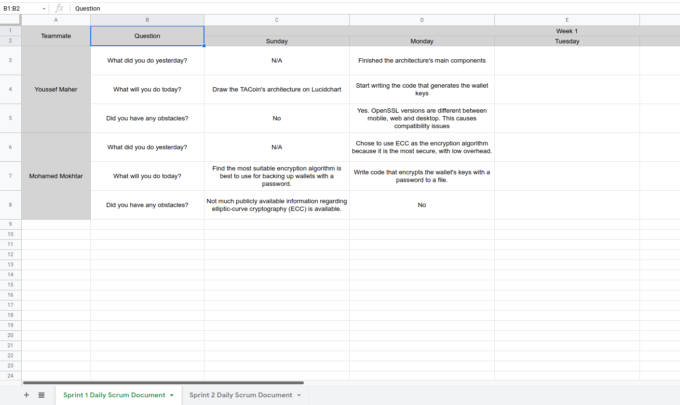

The sprint document for sprint 2 can be found [here](https://docs.google.com/document/u/0/d/1d1KdLVx8HhLLajzjPVwmWNQXUzcDx64URwjjUd1jNdQ/edit): <https://docs.google.com/document/u/0/d/1d1KdLVx8HhLLajzjPVwmWNQXUzcDx64URwjjUd1jNdQ/edit>

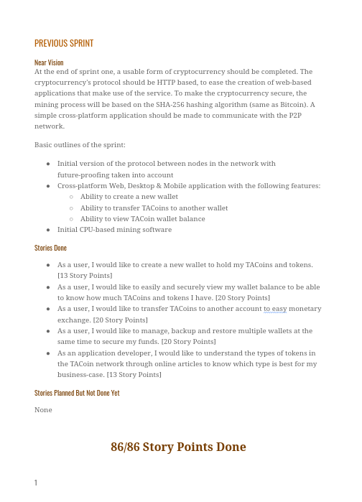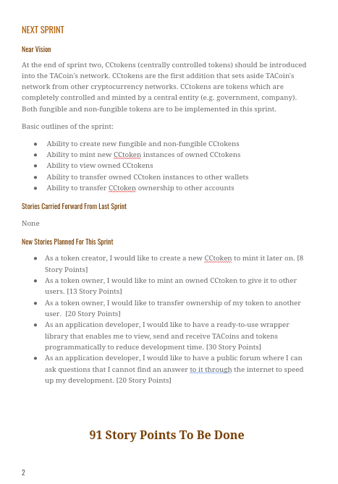

# Using Jira

### Design your own workflow and clearly indicate your rationale and Rules used in the README.md

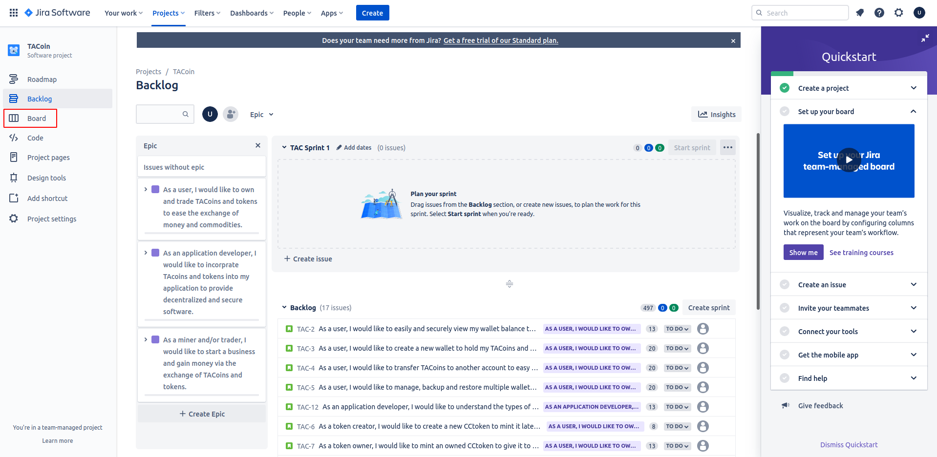

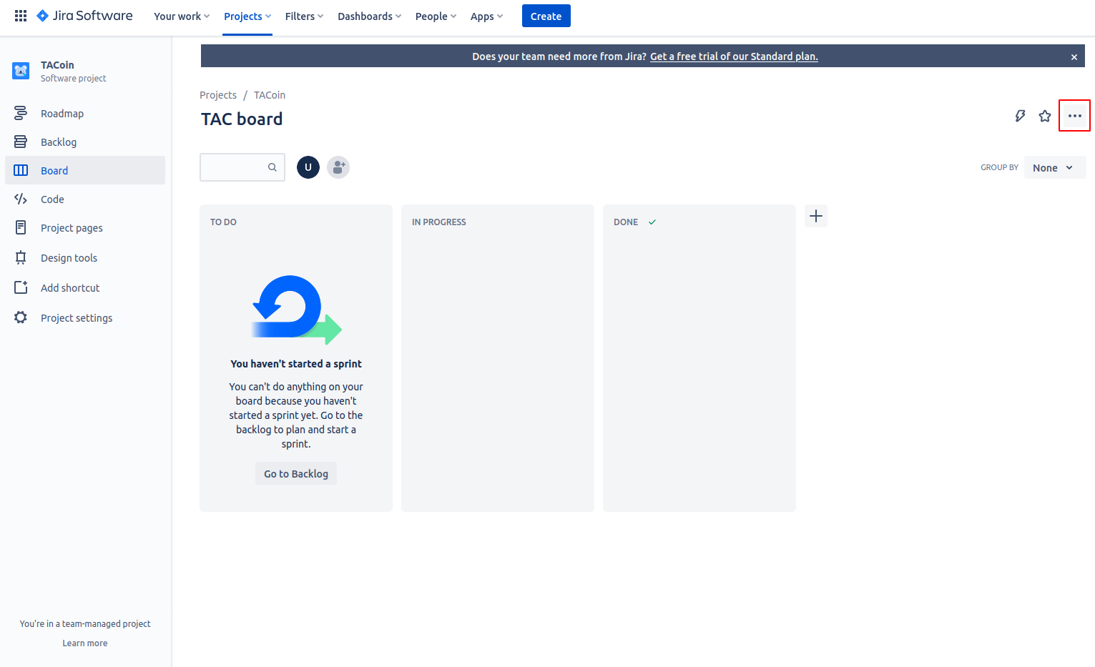

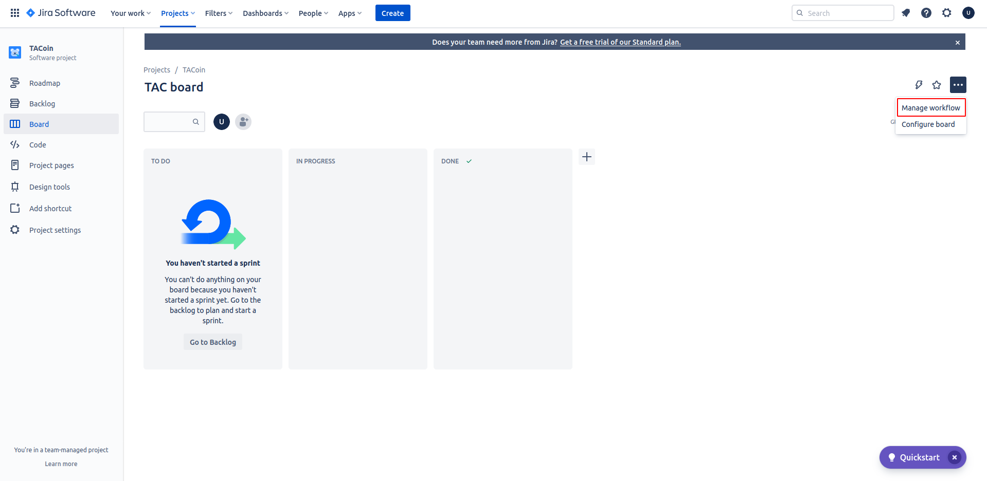

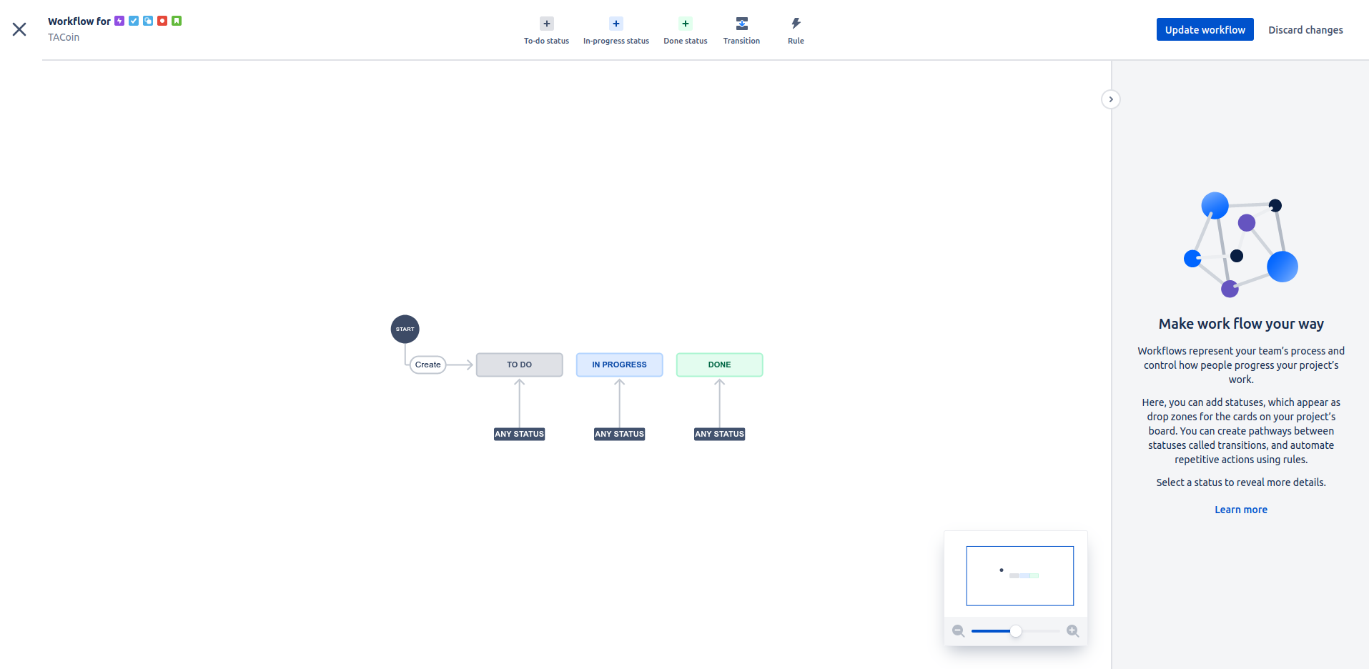

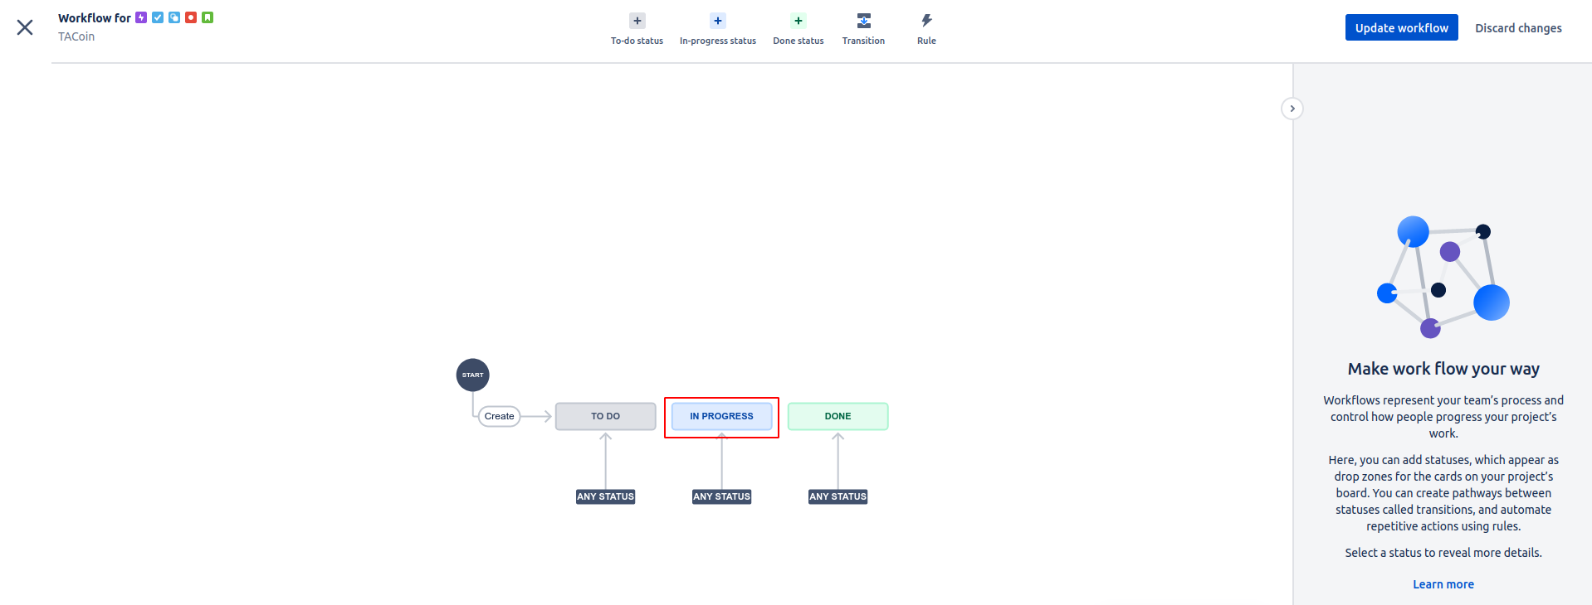

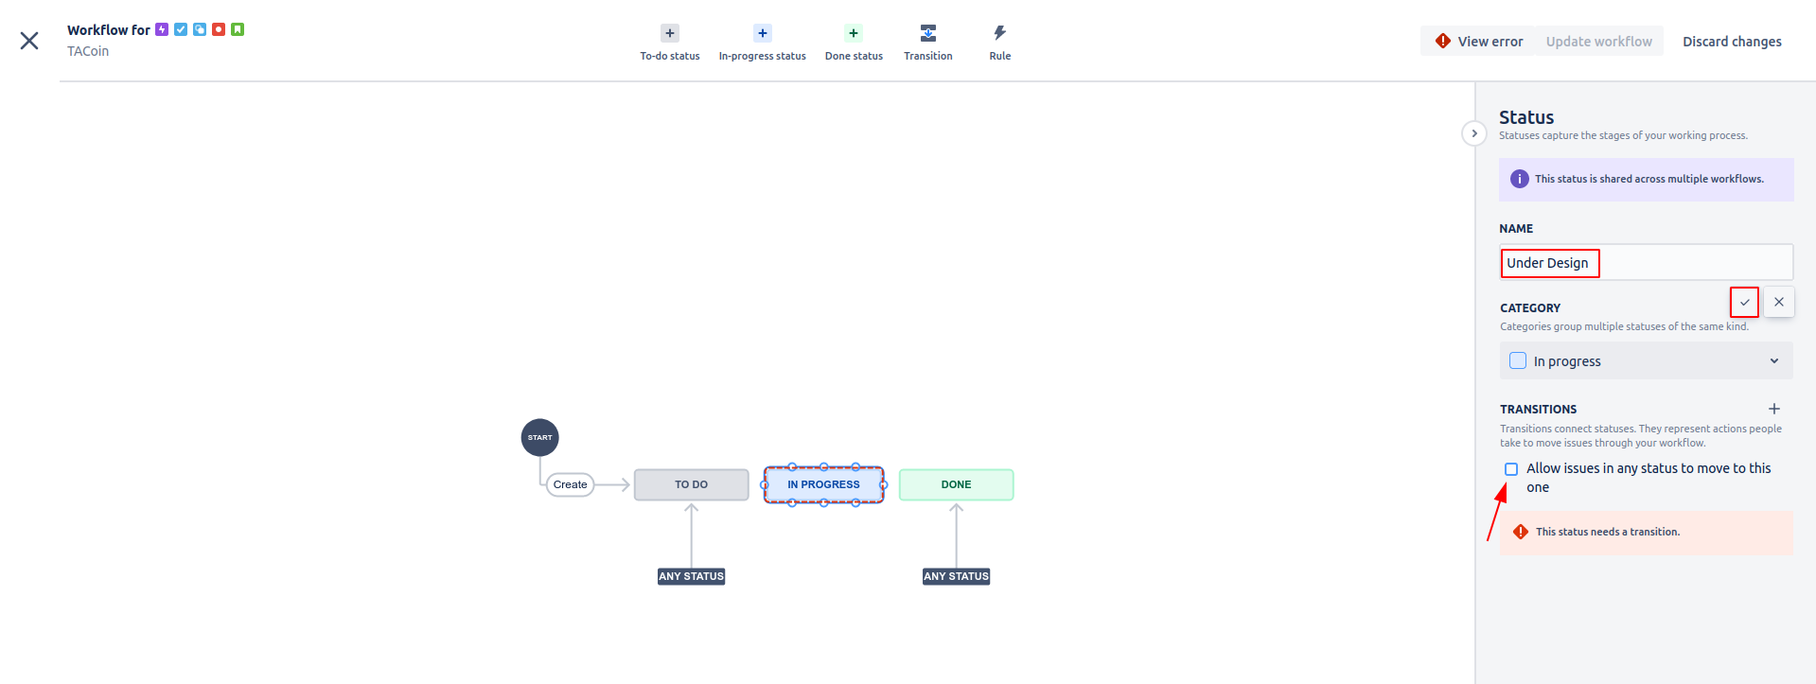

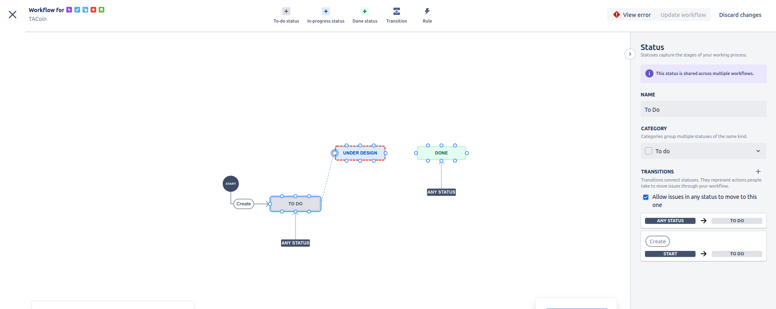

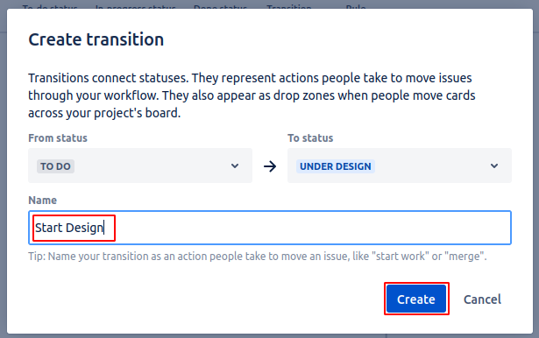

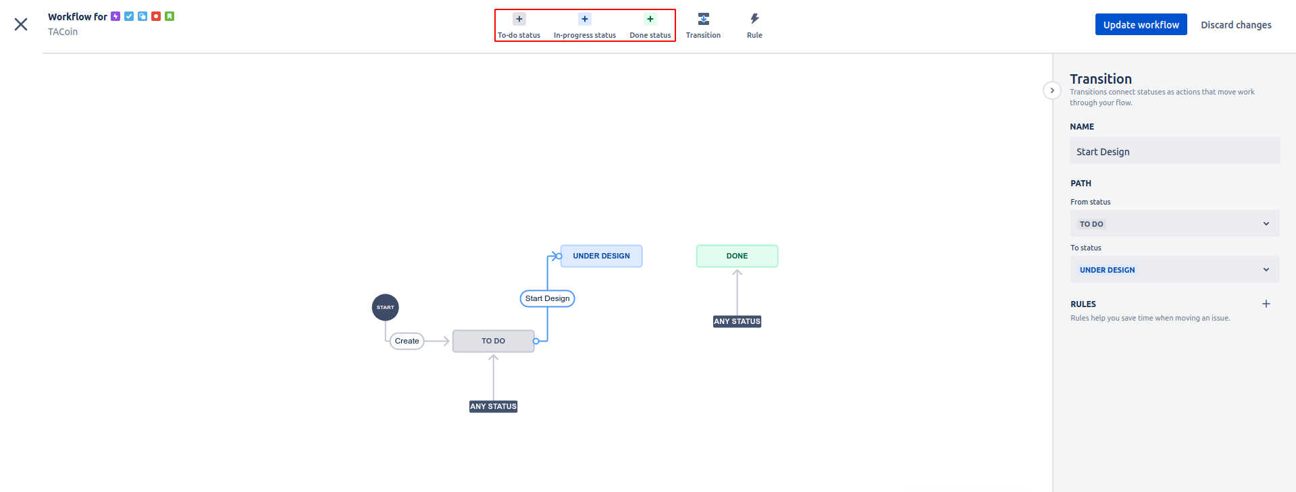

The same was repeated for the rest of the workflow:

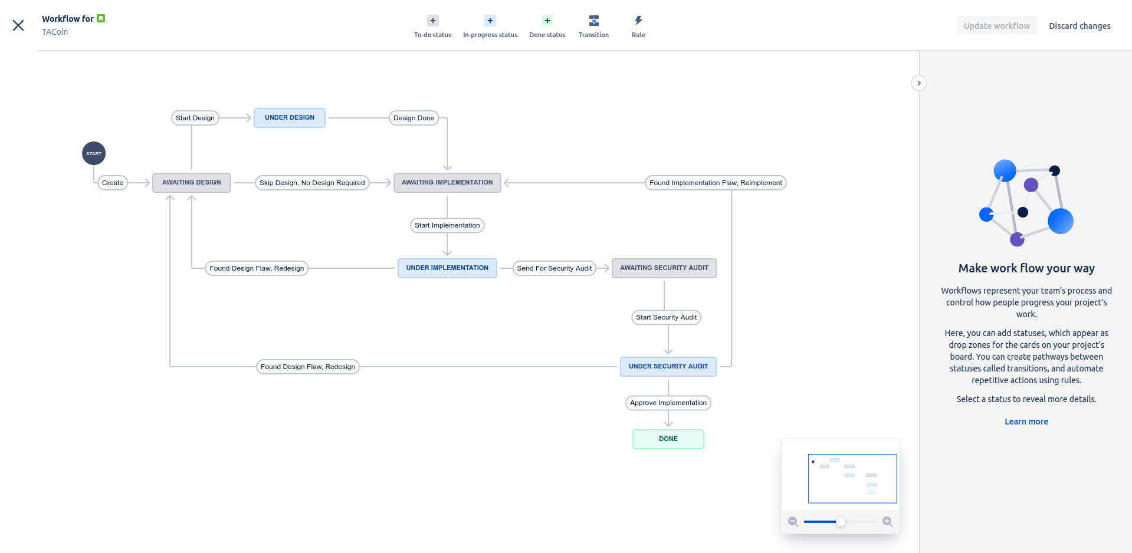

Multiple rules were added:

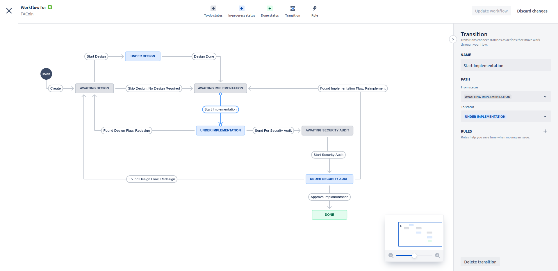

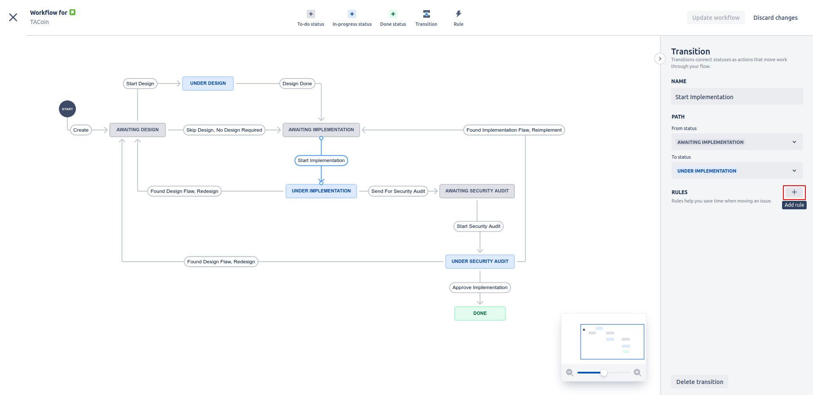

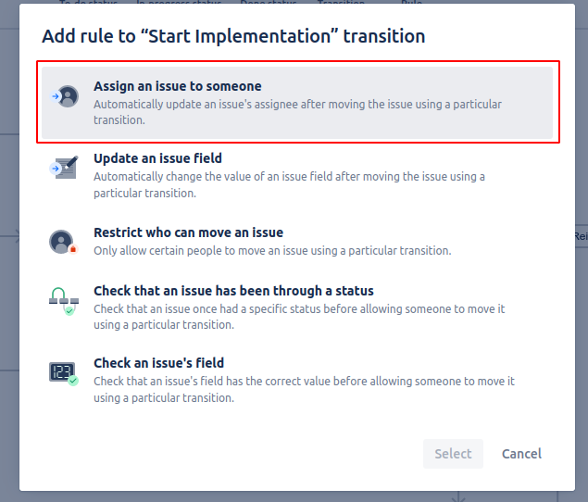

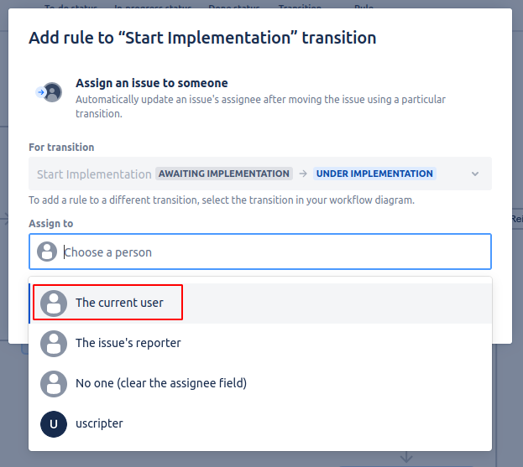

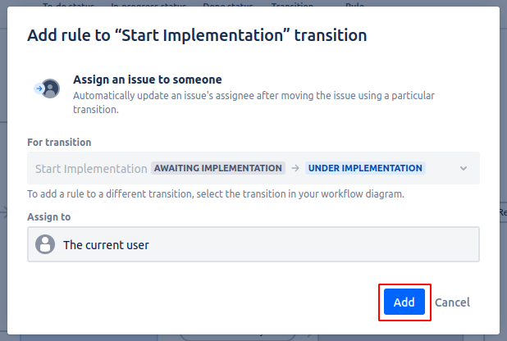

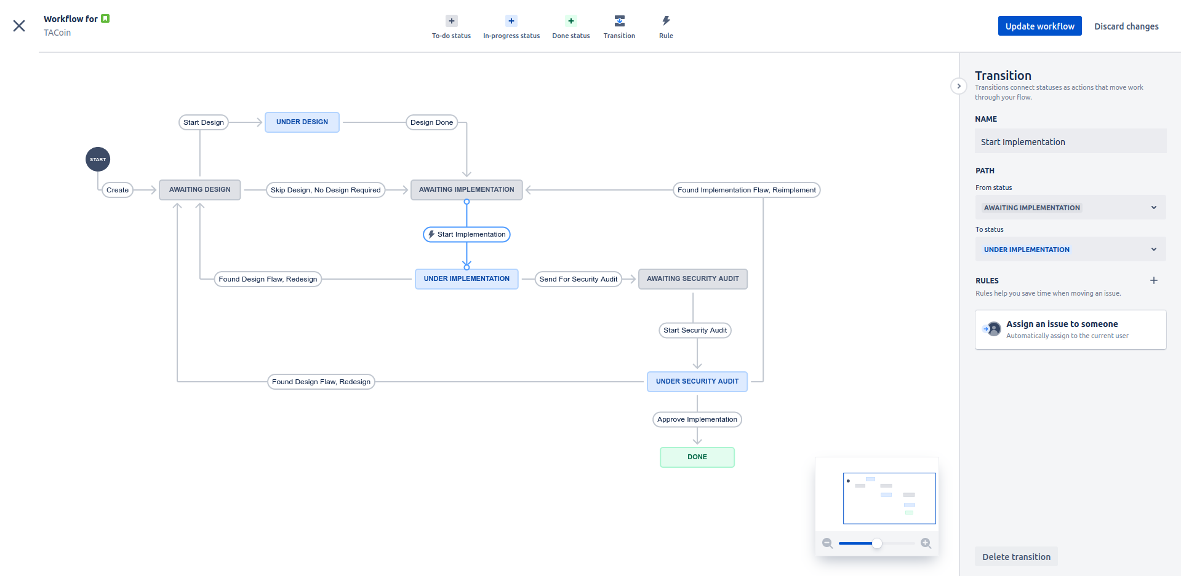

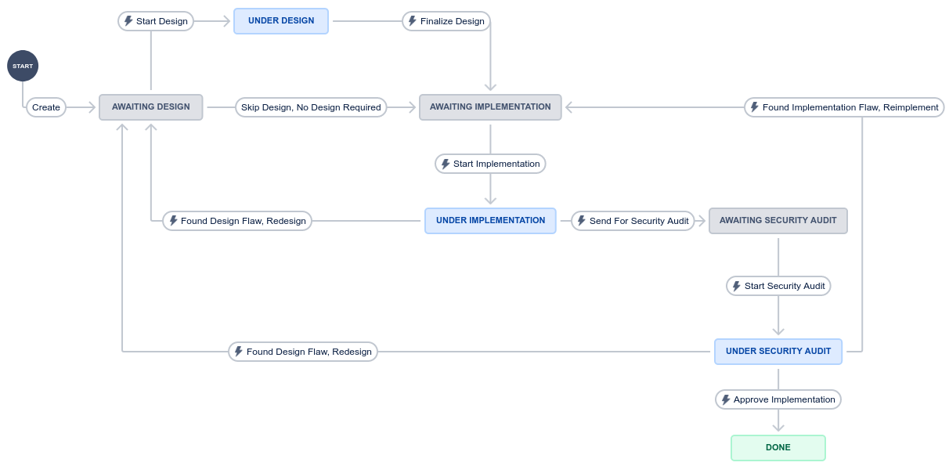

The same was done for the other transitions. The rules on the transitions are:

* Create: No rules
* Start Design: Automatically assign to current user
* Skip Design, No Design Required: No rules
* Finalize Design: Automatically clear the assignee field + Only the assignee can use this transition
* Start Implementation: Automatically assign to current user
* Found Design Flaw, Redesign: Automatically clear the assignee field + Only the assignee can use this transition
* Found Design Flaw, Redesign: Automatically clear the assignee field + Only the assignee can use this transition
* Send For Security Audit: Automatically clear the assignee field + Only the assignee can use this transition
* Start Security Audit: Automatically assign to current user
* Found Implementation Flaw, Reimplement: Automatically clear the assignee field + Only the assignee can use this transition
* Approve Implementation: Automatically clear the assignee field + Only the assignee can use this transition

#### For Sprint 1

### Pull stories into your sprint backlog

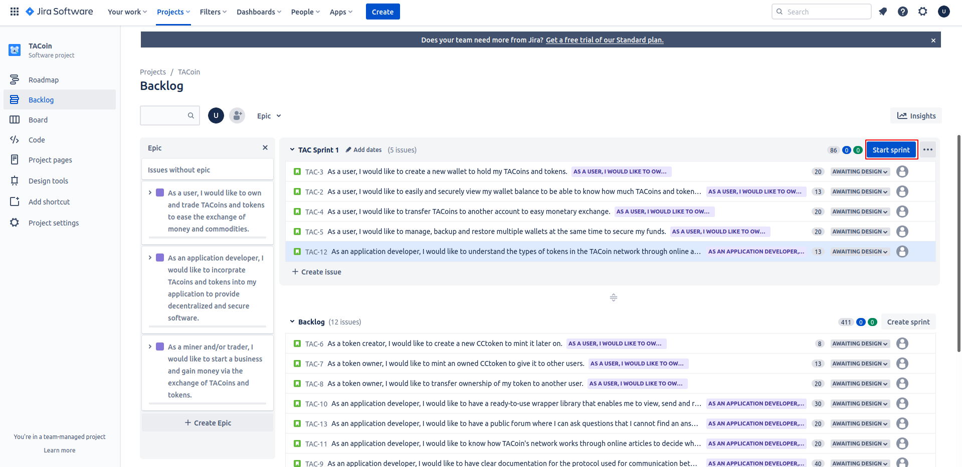

### Decompose stories into sub-stories if needed

Not needed

### Put the sprint tasks onto a Kanban board

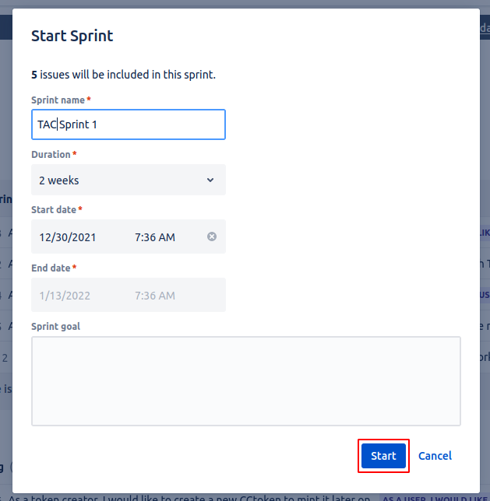

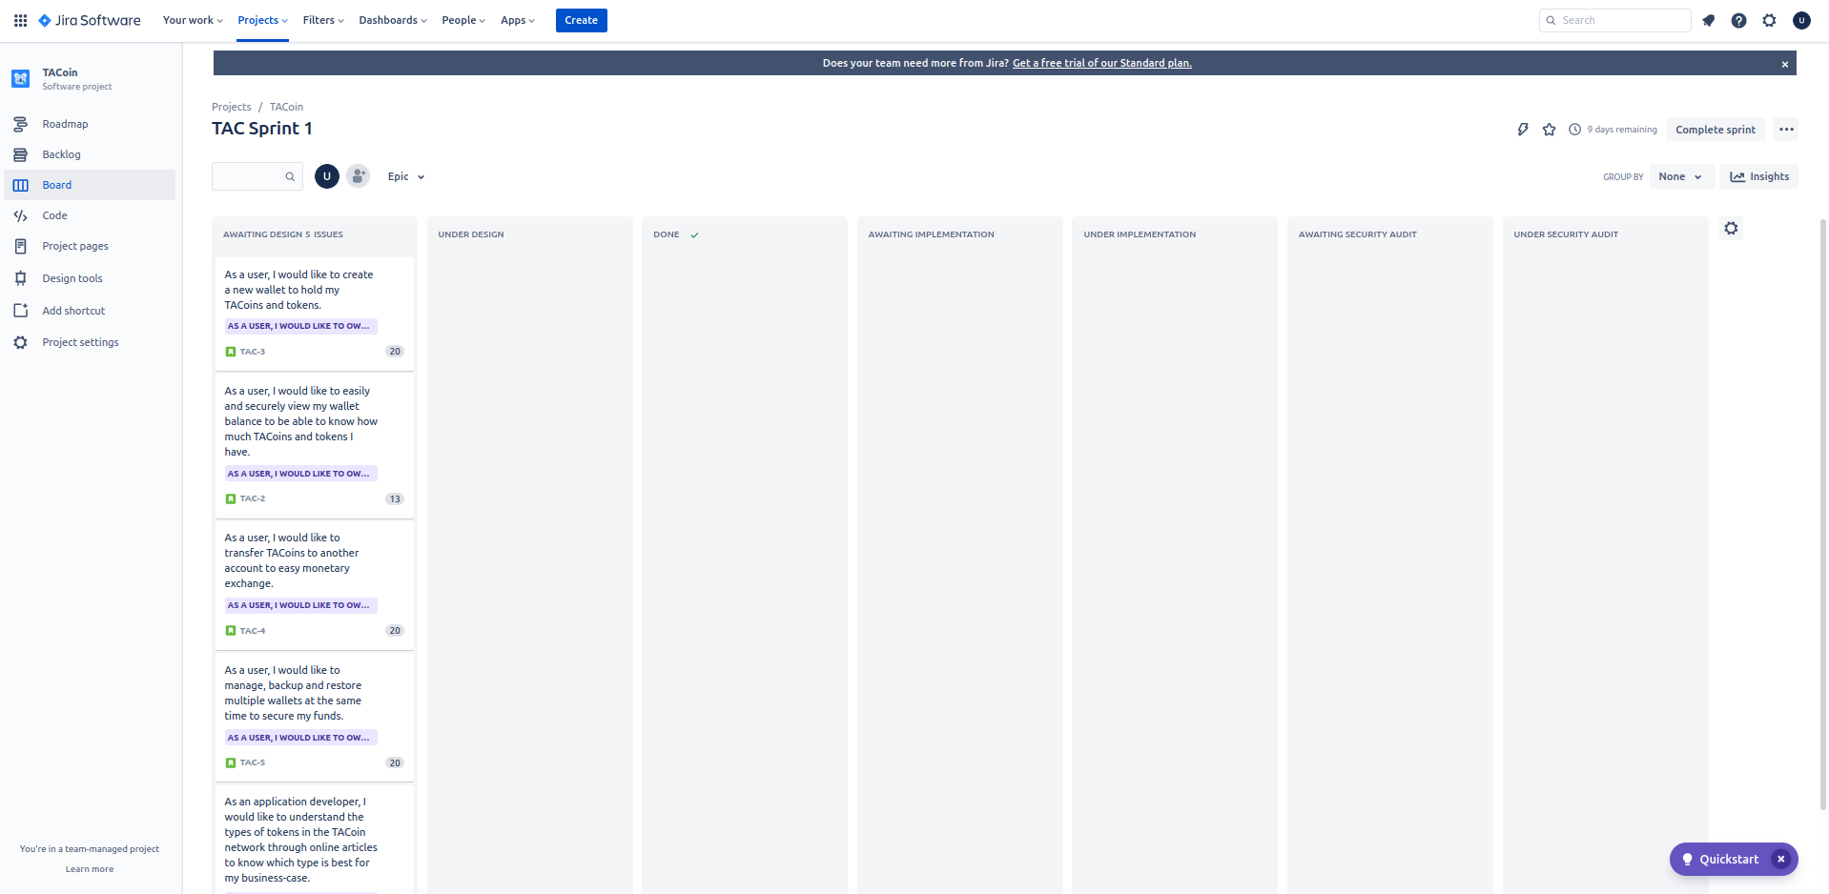

### Provide screenshots of what the Kanban chart would look like on 3,5,8,12 days

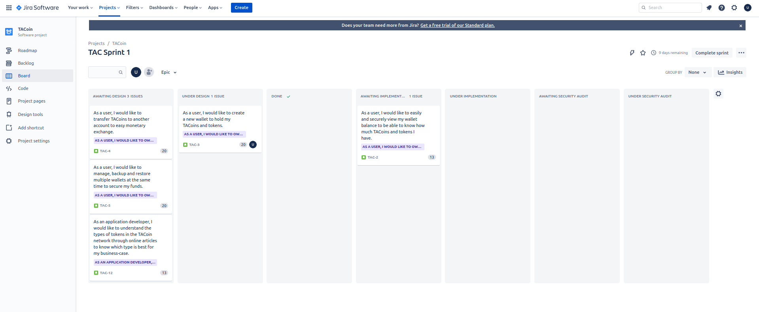

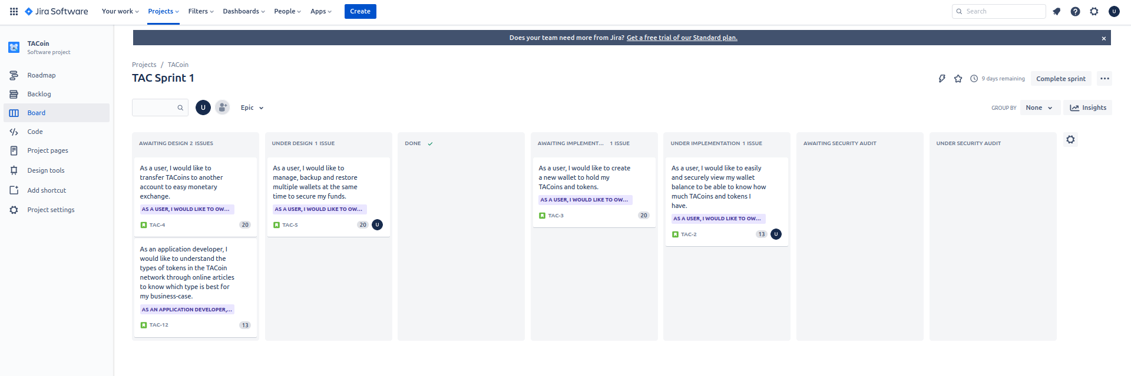

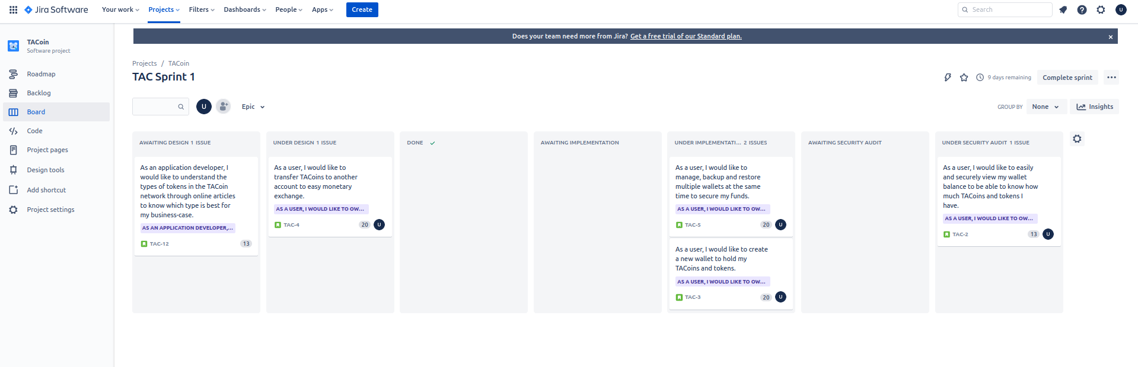

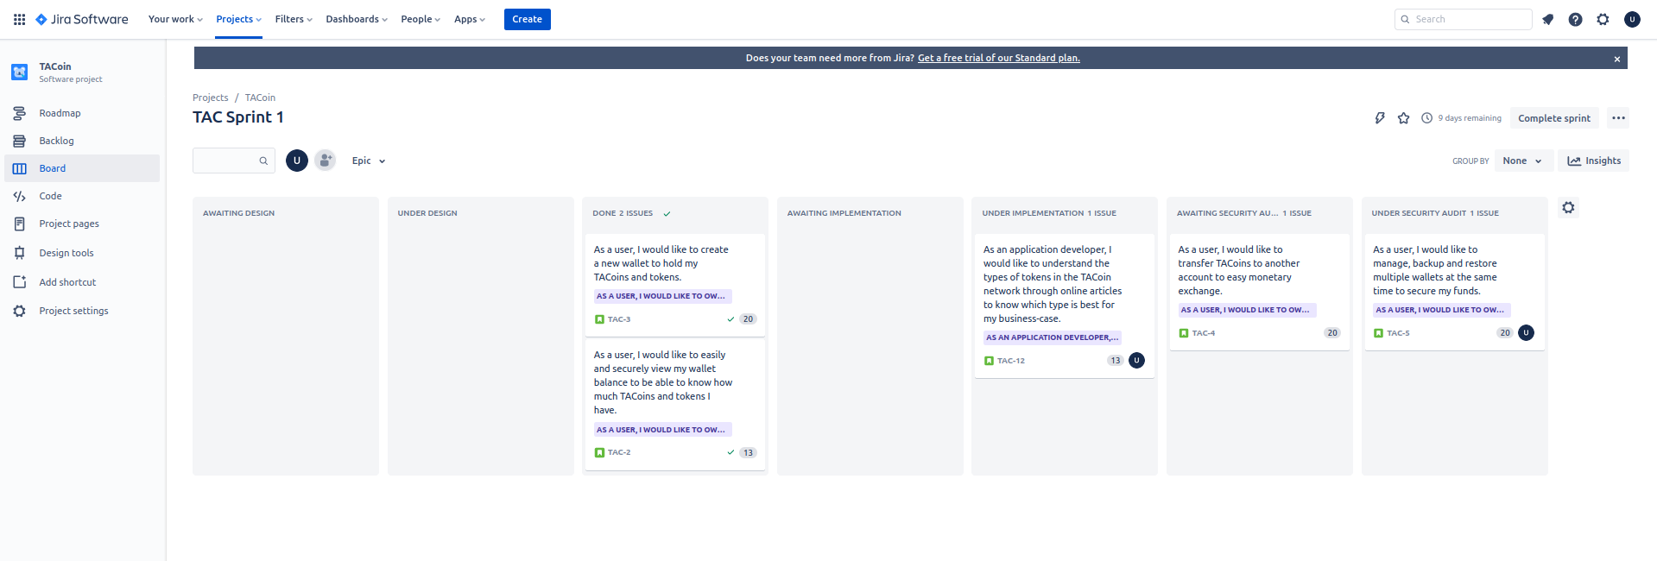

#### For Sprint 2

### Pull stories into your sprint backlog

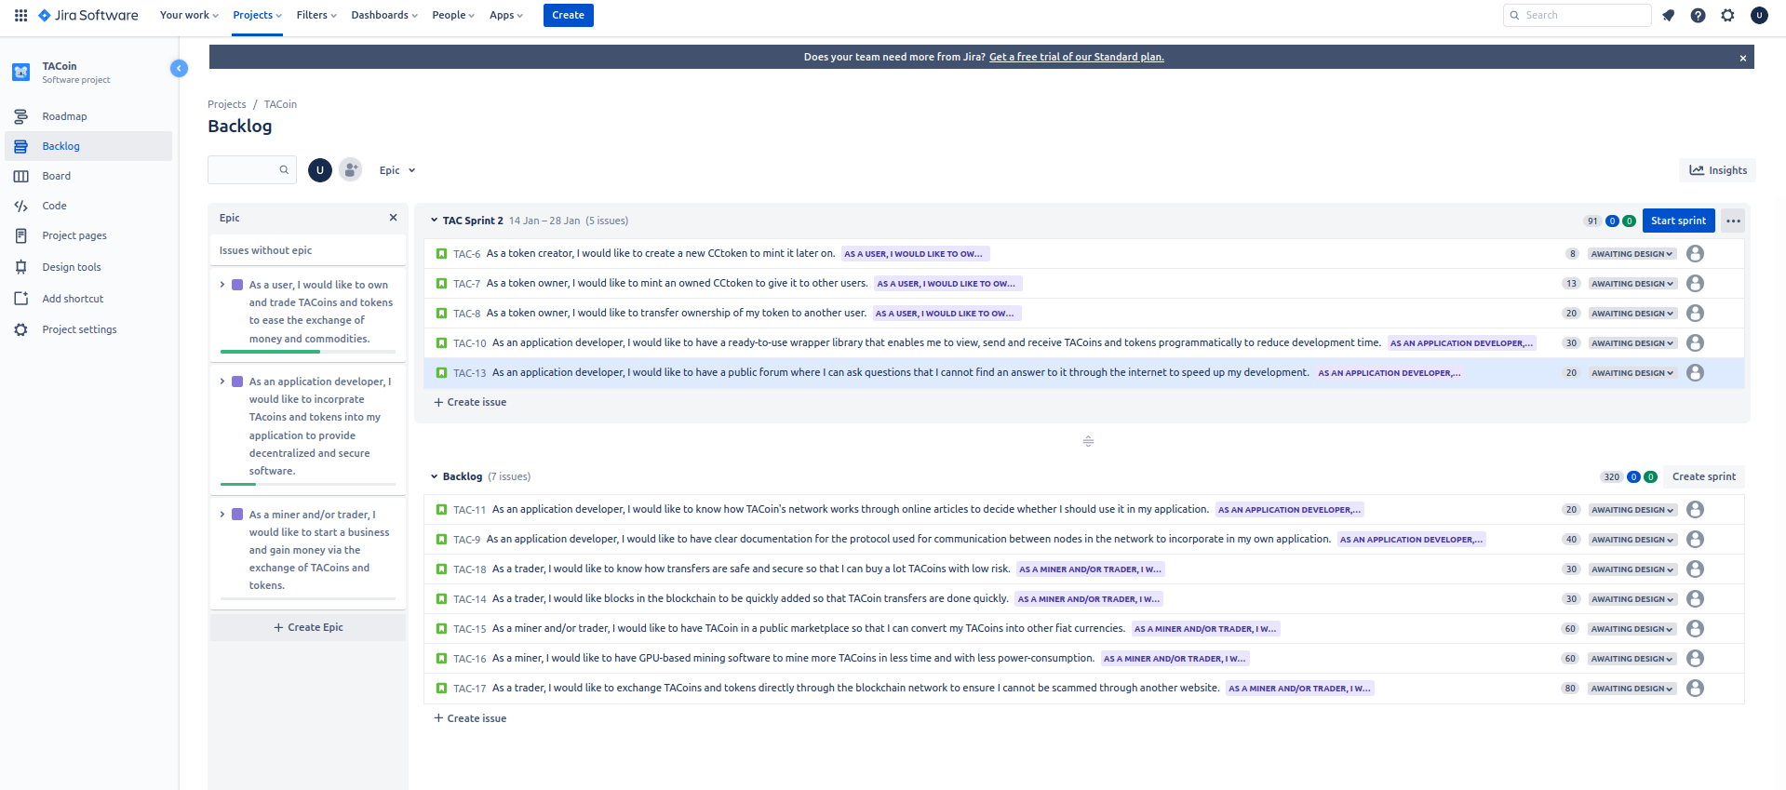

### Decompose stories into sub-stories if needed

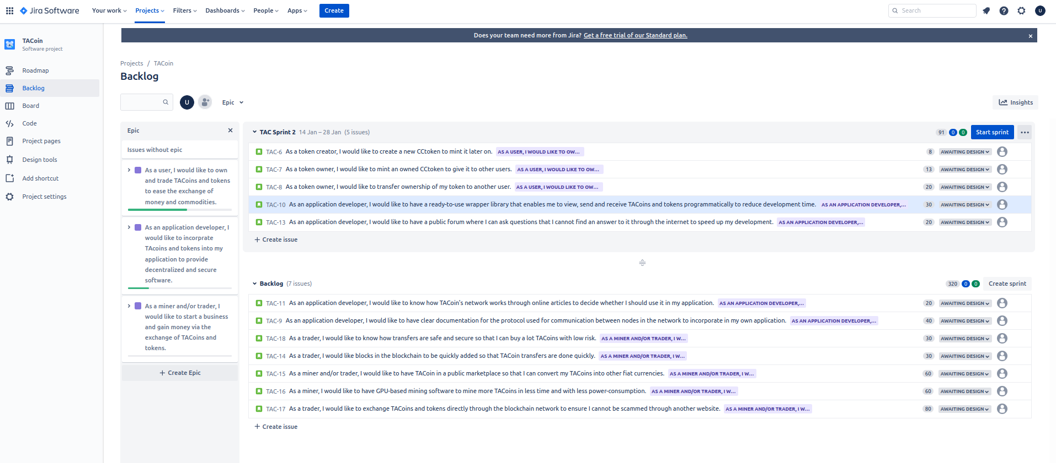

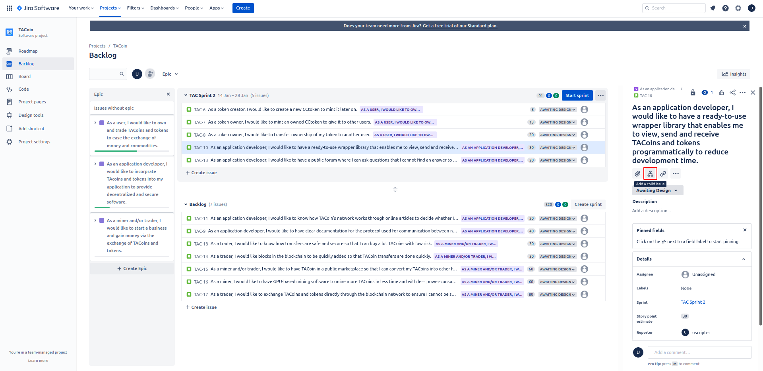

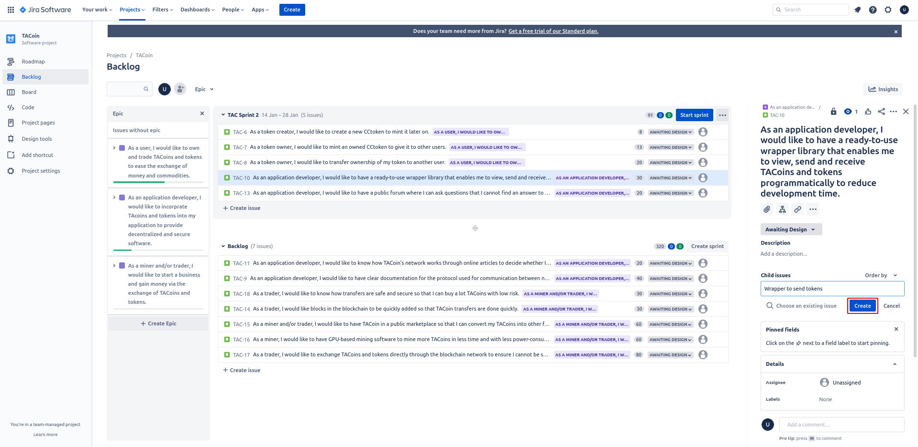

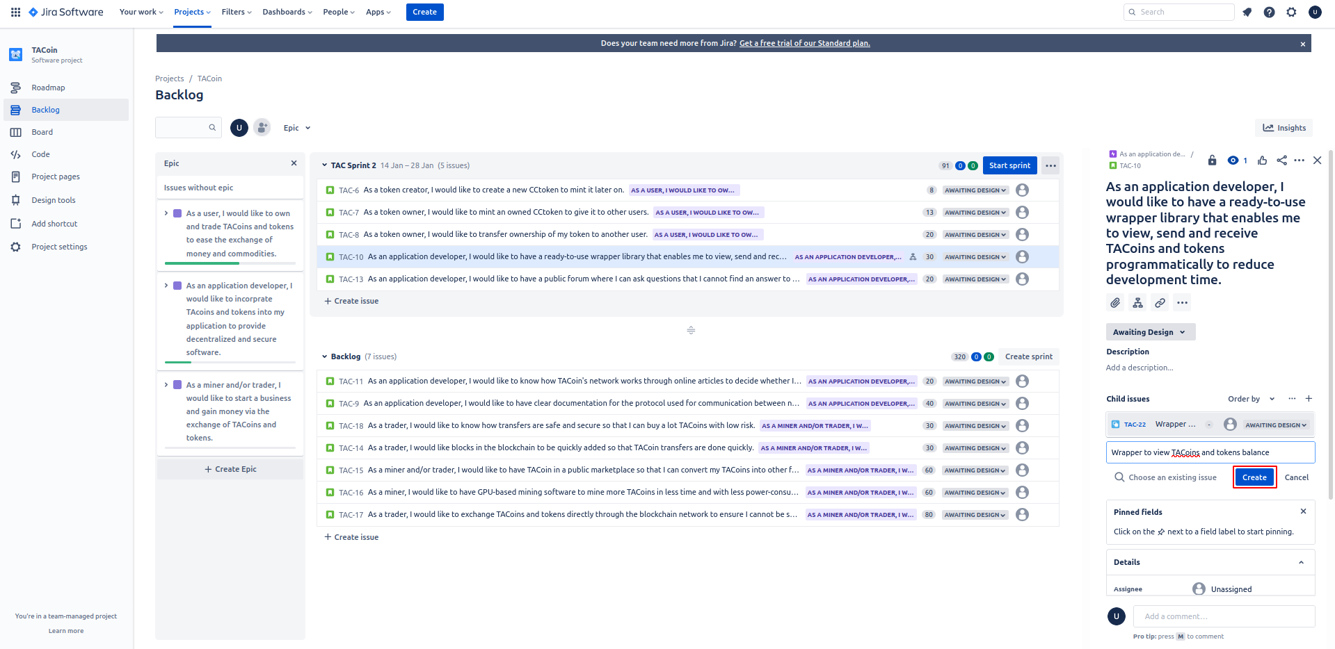

### 

### Put the sprint tasks onto a Kanban board

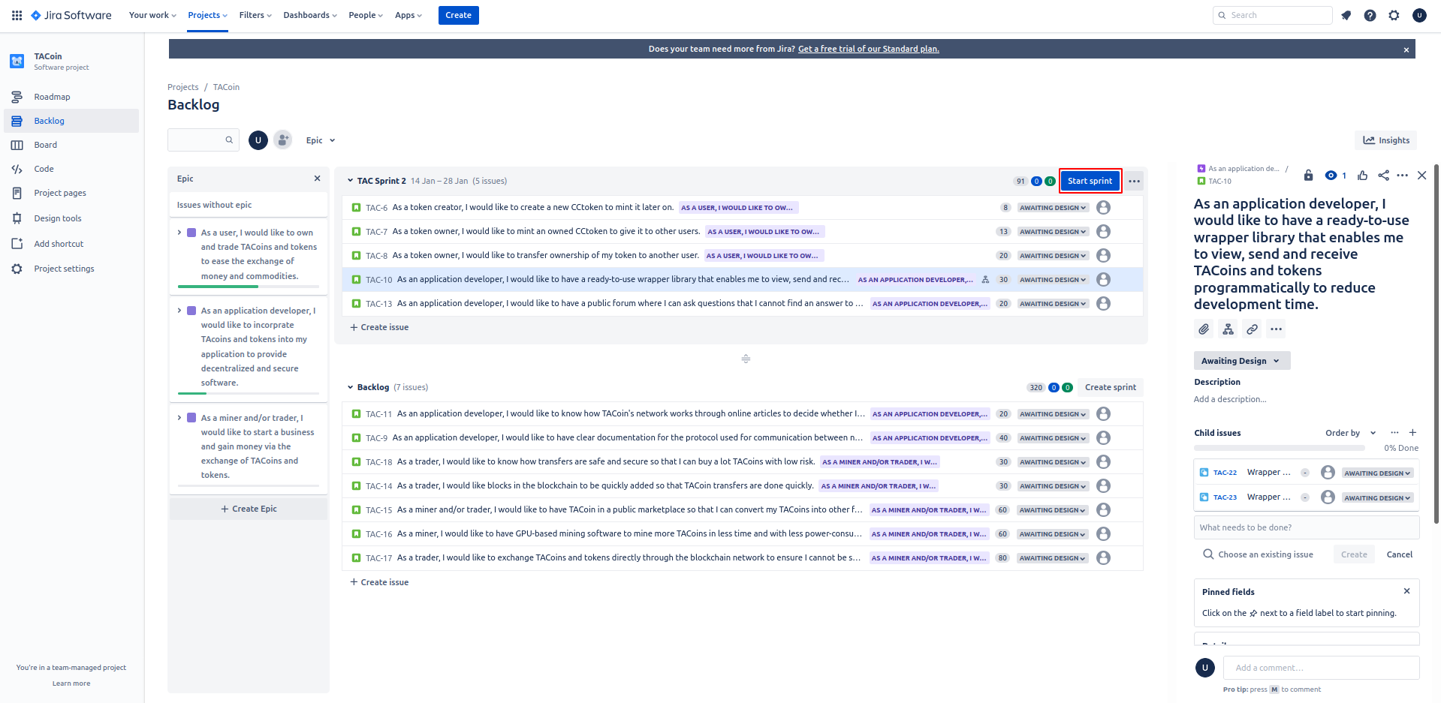

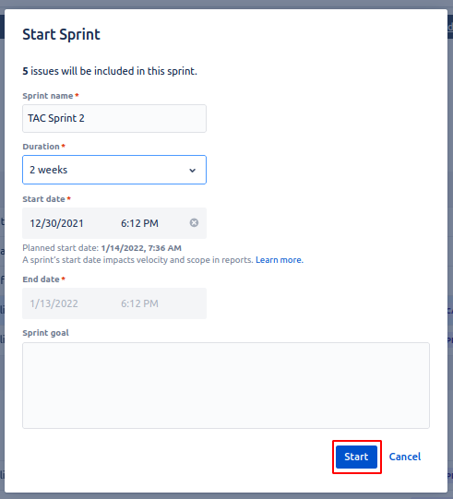

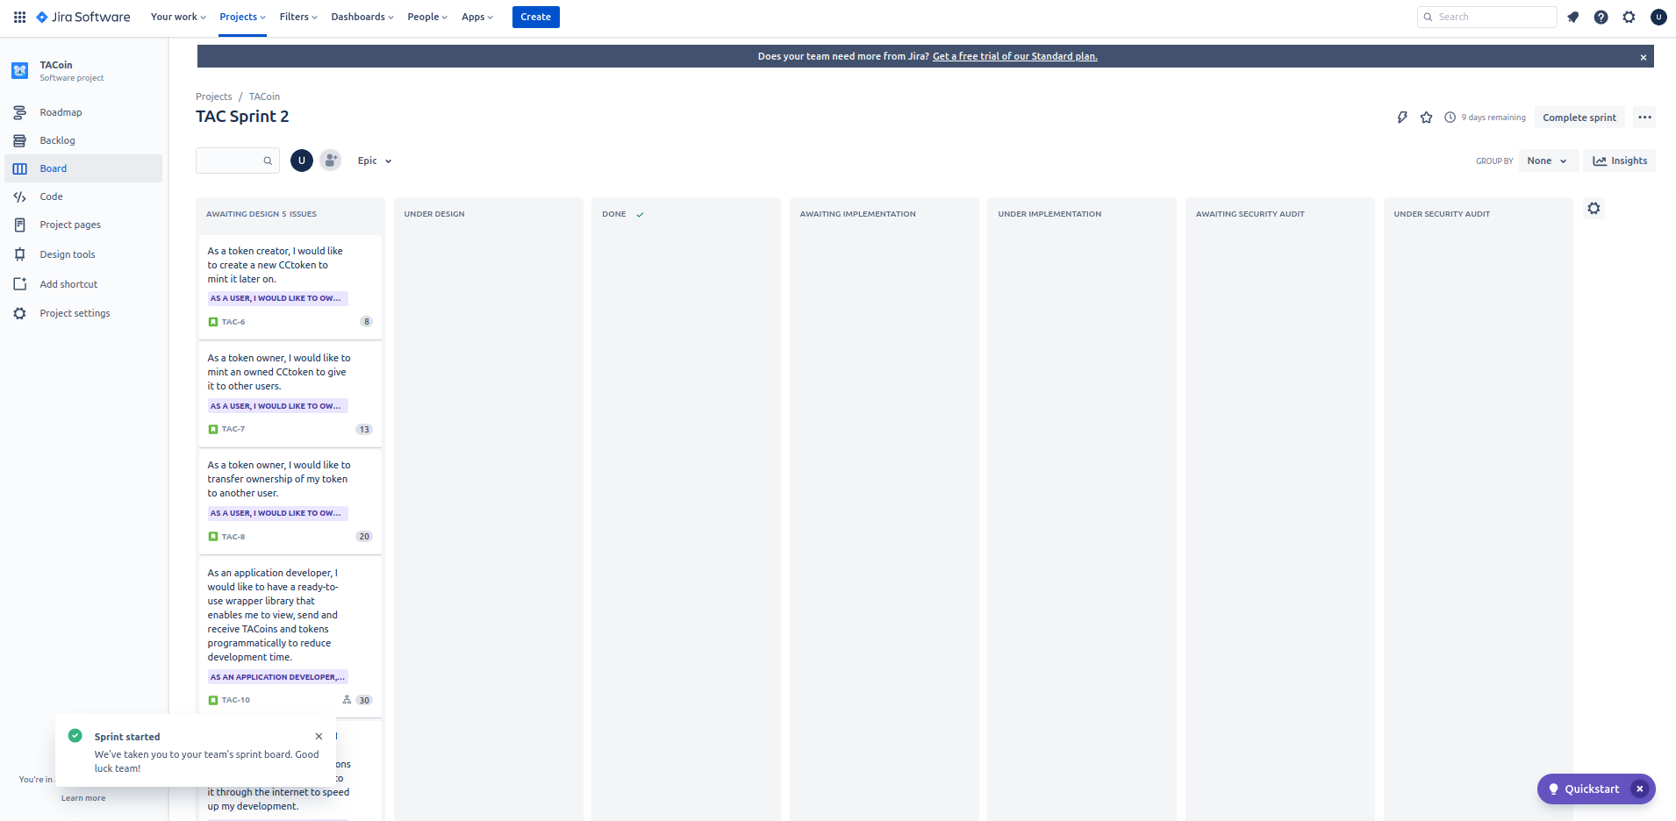

### Provide screenshots of what the Kanban chart would look like on 3,5,8,12 days

